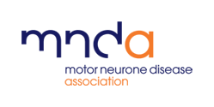

“Inclusion involves a journey from seeing it as a problem outside to be dealt with to seeing it as a challenge that starts inside. That applies to us as individuals as much as it does to the organisations that we work in. Once that is understood everything changes and anything is possible”. Usman Khan-Chair of Trustees (2022-)

Our journey towards inclusion
-a story of our times

Our destination

Inclusion is a way of working, a way of doing and a way of being. All of which will change and evolve as the world in its turn changes and evolves. We will, however, make progress and know that we are going in the right direction if by the end of 2024:

- We understand the communities that we have the potential to help and are designing and delivering the support, services and opportunities that they need.
What have we missed? Please do drop us a line with your thoughts.
- New and emerging barriers to participation are, once known, quickly addressed
- HSC Inequalities in relation to MND are a thing of the past.
- Our decisions are informed by a comprehensive data set.
- Our network groups and forums are vibrant, over-subscribed and exerting a responsible influence on what we do and how we do it.
- We are seen as a beacon for inclusion, an organisation that lives and breathes its values, a place where people feel they belong

A bit of background

Our journey started in 2017 when we brought together a number of like-minded people, sought the views and opinions of many others and created the MND Association’s first ever Equality Diversity and Inclusion Strategy. Endorsed at the highest level in early 2018, the strategy was designed to deliver four main outcomes over a three-year period:

- People with and affected by MND feel able and do use Association and statutory services
- All of our people, both individually and collectively, are committed to and are working towards ensuring that everything we do embraces equality and values diversity
- Our trustees, directors and senior managers proactively demonstrate and champion our commitment to equality, diversity and inclusion, both internally and externally
- Our partners and stakeholders share our commitment to equality, diversity and inclusion

Over the following couple of years we made great progress and really began to make a difference. People talked about equality, were interested in what we were doing and started to ask questions of us and of themselves and then there was Covid!
Just some of the things we have done or are doing……..

- Created network groups or forums for our LGBTQIA+, BAME & hidden disabilities communities
- Designed and rolled out a multi-channel awareness raising programme
- Built a team of Inclusion Champions
- Developed and delivered training
- Made a commitment to only use accessible venues
- Launched our extending our reach programme
- Registered for Disability Confident
- Became a Stonewall Diversity Champion
- Formed a team of Mental Health First Aiders
- Launched a comprehensive staff wellbeing programme
- Reviewed and revised our approach to recruitment

Of course, things slowed down as we focussed on the immediate and emerging needs of people with and affected by MND, our staff and our volunteers. But they didn’t stop and we continued to work away in the background developing a wellbeing programme, taking small steps, thinking, planning and agreeing that investment was needed if we were to regain the momentum that had been lost. In 2021 we changed the name to Diversity Equity and Inclusion (DEI) and appointed a Head of DEI, shortly followed by a Community Engagement Partner (CEP).
A bit too simple? Please do let us know what you think.
Looking to the future

With our new Head of DEI in post, we began once again to move forward at pace against a series of high level aims that led in 2022 to another name change and the creation of a very simple three-part Inclusion Strategy.
We will provide services and support and undertake research in ways that are inclusive and accessible by:

- Engaging with, understanding and responding to the needs of local, regional and national communities
- Reaching out to those in need and removing actual and perceived barriers to participation
- Being creative and innovative

We will identify and address MND specific health and social care inequalities by:

- Ensuring that there is equity of access to multidisciplinary care across England, Wales & Northern Ireland
- Enabling our Care Centres and Networks to meet the needs of service users and potential service users
- Empowering Health and Social Care Professionals to understand and adopt best practice

We will empower all of our people to embrace Inclusion and demonstrate their commitment by:

- Recruiting from the widest possible talent pool
- Informing, training and equipping staff and volunteers
- Proactively engaging with and responding to the needs of our internal communities
The Strategy is closely aligned to the Association’s Promises generally and Promise Five, “no one faces MND alone”, in particular. At this stage we are focussing on three key initiatives as part of this promise.
Is there something more urgent? Please do let us have your ideas.
- Community engagement
- Health and Social Care (HSC) inequalities
- Inclusion related learning

We are also working with the People Culture and Co-creation foundation programme to change the way we do things.

From ambition to action
“What is important to me is that our Association is here for everyone. As human beings, we are all individuals and the service we provide to people living with and affected by MND, our supporters and our volunteers should reflect and respect that individuality-whatever its backstory or influences. We will do that best if we celebrate the benefits of diversity in all aspects of our work and approach each situation without assumptions but with an enquiring mind” Sally Light-Chief Executive

Ambitions and aspirations are essential if we are to be creative and achieve change but they only make a real difference when underpinned by a series of plans, activities and actions. Ours include:

- Analysing data to understand the make-up of local communities
- Undertaking a range of initiatives to address the needs of the most diverse and underrepresented local communities
- Enabling our groups and branches to extend their reach across England, Wales & Northern Ireland
- Working with community leaders and influencers to ensure that our services and the support that we offer meet the needs of their communities
- Ensuring that the imagery and narrative we use reflects the diversity of the population
- Identifying and addressing HSC Inequalities that exist amongst MND specific services and in particular those provided by:
-Our Care Centres and Networks
-Community Specialists
-HSC professionals with a particular interest in or focus on MND
- Creating and delivering a learning programme that meets the needs of our staff and volunteers
- Achieving Disability Confident-Employer status
- Meeting the needs of people with hidden disabilities and conditions
“Cultural change in any organisation needs continual nurturing and engagement of people at all levels. We have made significant progress and know that we have further to go”. Richard Coleman- Chair of Trustees (2018-2022)

- Embedding Communication Access
- Qualifying for the Stonewall Workplace Equality Index
- Embedding inclusive staff and volunteer recruitment practices
- Extending our comprehensive staff wellbeing programme to volunteers
- Engaging with, contributing to and learning from other organisations and networks
- Auditing new and existing services and products to ensure that they are truly accessible & inclusive
- Increasing volunteer, member and service user involvement in our network groups and forums

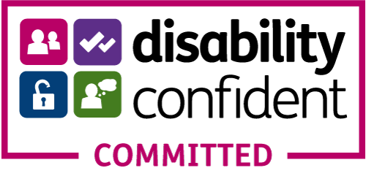
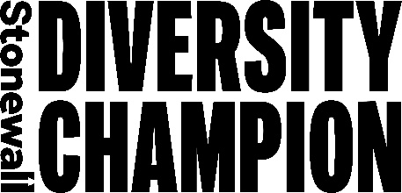
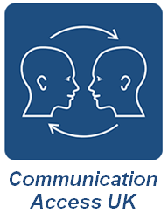
“I am pleased to have been involved from the early stage discussions about the Association’s approach to becoming an inclusive and welcoming organisation, supporting everyone affected by MND directly and pushing for change in health and social care services to achieve this. To now see a clear plan of action, a team developed, and a Board to support this team is a fantastic achievement and a clear signal as to how important this work is. There is a challenging road ahead in this area, the change required at times will be significant, but I am looking forward positively to handing on the baton to the next Board champion for diversity and inclusion and seeing the Association grow from strength to strength in this area”. Heather Smith-Trustee Inclusion Champion (2020-2022)

We would like you to…..

…ask yourself one simple question on a regular basis “What can I do today to make the Association and my part in it more inclusive”?

Want to know more or get involved?

Please do get in touch, we would love to have a conversation
What will you be doing or have done? We would really like to hear from you.

E. john.gillies@mndassociation.org
T. 01604 600 830
SMS/WhatsApp 0777 569 1712

John Gillies-Wilkes
Head of Inclusion and Wellbeing
12th July 2022

