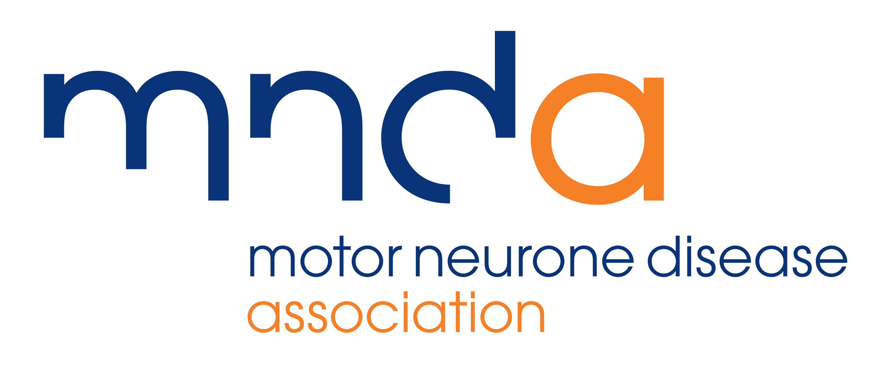

Note: Always call the paper beforehand to find out who is the best person to email the story to.

[DATE]

HEADLINE [USE YOUR LOCAL PAPER FOR INSPIRATION!]

A [YOUR PROFESSION] from [WHERE] is hoping to raise [AMOUNT] for the Motor Neurone Disease (MND) Association by [organising a/taking part in] [EVENT].

[NAME], will [DO WHAT?] at [VENUE] on [DATE].

[NAME] is raising money for the MND Association because [REASONS WHY/PERSONAL STORY].

He/She said: “HOW YOU’RE FEELING ABOUT THE EVENT, WHY IT’S IMPORTANT TO RAISE MONEY FOR THE MND ASSOCIATION ETC…]”

Motor neurone disease (MND) is a fatal rapidly progressing disease that affects the brain and spinal cord, attacking the nerves that control movement so muscles no longer work. It kills a third of people within a year and more than half within two years of diagnosis.

It’s a devastating disease that affects up to 5,000 adults in the UK at any one time and kills six people every day. There is no cure.

The MND Association focuses on improving access to care, research and campaigning for those people living with or affected by MND in England, Wales and Northern Ireland.

Denise Davies, Head of Community Fundraising at the MND Association, said: “Without our amazing supporters, the MND Association simply would not be able to provide its vital support services, fund research to find a cure and campaign and raise awareness of MND. Together we are making a real difference for people affected by this devastating disease.”

For more information about MND and the MND Association please visit www.mndassociation.org

ENDS

Note to Editors:

For further information on the above and to arrange an interview, please contact [YOUR NAME] on [YOUR NUMBER]

For more information about the MND Association please contact the
MND Communications Team.
Phone: 01604 611838 or email: communications@mndassociation.org
www.mndassociation.org
About motor neurone disease (MND):

- MND is a fatal, rapidly progressing disease that affects the brain and spinal cord.
- It attacks the nerves that control movement so muscles no longer work. MND does not usually affect the senses such as sight, sound, feeling etc.
- It can leave people locked in a failing body, unable to move, talk and eventually breathe.
- Over 80% of people with MND will have communication difficulties, including for some, a complete loss of voice.
- It affects people from all communities.
- Around 35% of people with MND experience mild cognitive change, in other words, changes in thinking and behaviour. A further 15% of people show signs of frontotemporal dementia which results in more pronounced behavioural change.
- It kills a third of people within a year and more than half within two years of diagnosis.
- A person’s lifetime risk of developing MND is around 1 in 300.
- Six people per day are diagnosed with MND in the UK.
- It affects up to 5,000 adults in the UK at any one time.
- It kills six people per day in the UK, this is just under 2,200 per year.
- It has no cure.

The MND Association was founded in 1979 by a group of volunteers with experience of living with or caring for someone with MND. We are the only national charity in England, Wales and Northern Ireland focused on MND care, research and campaigning.

We improve care and support for people with MND, their families and carers.

We fund and promote research that leads to new understanding and treatments, and brings us closer to a cure for MND.

We campaign and raise awareness so the needs of people with MND and everyone who cares for them are recognised and addressed by wider society.
For more information visit www.mndassociation.org

