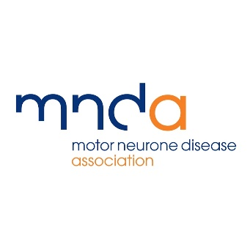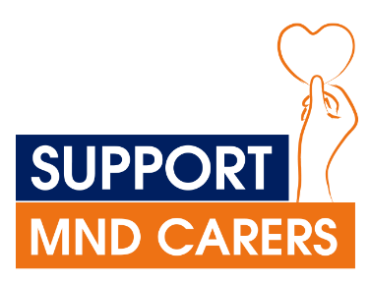

**Get involved in the Support MND Carers campaign locally**

Getting started

1. **Raise awareness of carer’s assessments locally**

All unpaid carers have the right to a carer’s assessment. An assessment enables an unpaid carer to tell adult social care services how their caring role could be made easier.

However, our [Carers Report](https://www.mndassociation.org/sites/default/files/2023-02/Carers-Report-External-version.pdf) found 40% of unpaid carers of people with MND were unaware of their right to a carer’s assessment.

This is where you come in! Help raise awareness by sharing information such as this [infographic](https://www.mndassociation.org/sites/default/files/2023-05/Carer%27s%20assessment%20infographic%20v3.png) on social media and among your local networks. You could encourage your local branch/group to share it in their newsletter or on their social media too. Have a friendly contact at the local newspaper or news site – they could share it too!

1. **Contact your local councillors about the Support MND Carers campaign**

We’ve created this handy [template letter](https://www.mndassociation.org/sites/default/files/2023-05/Supporter%20lobbying%20for%20local%20council.docx) to help you write to your local council to raise awareness of the Support MND Carers campaign.

1. **Fact finding on your local council website**

How easy is it for a busy unpaid carer in your community to find information about carer’s assessments on your local authority website? How many clicks will it take for them to get the information they need?

Find out for yourself by checking your council’s website – [find your council here.](https://www.gov.uk/find-local-council)

Not easy enough to find what you need? Raise concerns with the adult social services team - check out the staff directory or give the switchboard a call.

1. **Raise awareness with your local branch/group**

Work with your local branch/group to raise awareness of a carers right to a carer’s assessment. Could you ask the branch/group to share the [infographic](https://www.mndassociation.org/sites/default/files/2023-05/Carer%27s%20assessment%20infographic%20v3.png) on their group social media or in their branch newsletter?

[Find your local branch/group and their contact details here](https://www.mndassociation.org/support-and-information/local-support/branches/).

1. **Keep us in the loop!** Get advice or give us feedback by emailing [campaigns@mndassociation.org](mailto:campaigns@mndassociation.org).

Next steps

You’ve done a great job pushing for increased awareness of carer’s assessments locally – now let’s work to make sure carer’s assessments are effective.

Our research has found that when carers of somebody with MND finally get an assessment they can be inadequate. The assessor might not have a good understanding of MND and the impacts on a carer or what a carer is offered may be inappropriate.

1. **Write to your MP!**

Your MP can have a good deal of influence locally – especially if they belong to the same political party as the leadership of the local authority.

Ask your MP to write to the local authorities in your constituency to bring attention to this issue and ask some questions about carer’s assessments locally.

We have [this covering letter](https://www.mndassociation.org/sites/default/files/2023-05/Ask%20your%20MP%20to%20write%20to%20your%20local%20authority%20about%20carer%27s%20assessments.docx) for you to send to get your MP to send this [template letter for MPs to send to local authorities](https://www.mndassociation.org/sites/default/files/2023-05/MP%20template%20letter%20to%20local%20authorities.docx) on the Support MND Carers resource page.

1. **Organise a meeting with your local councillor/s**

Your councillors are accountable to you! If you’d like, you could organise a meeting with your councillors to discuss the Support MND Carers campaign and see what can be done to make sure carer’s assessments are as accessible and effective as possible.

Come armed with some facts and figures from the [Support MND Carers webpage](https://www.mndassociation.org/get-involved/campaigning/take-action/support-mnd-carers/support-mnd-carers-resources-for-supporters/) and report. Your councillors will also be interested to hear about what’s going on locally. You could touch base with your local branch/group or Association Visitor to collect anecdotal information and ensure that carers lived experiences are part of the conversation. A carer of somebody living with MND may be willing to accompany you to a meeting with councillors.

If you’ve been personally affected by MND you could consider sharing your own experience if you feel comfortable doing so.

If you would like help or advice [we’re only an email away](mailto:campaigns@mndassociation.org?subject=I'd%20like%20to%20meet%20my%20councillor%20to%20discuss%20support%20mnd%20carers) and happy to offer a telephone/video call catch-up.

Remember to check out the [Support MND Carers resource page](https://www.mndassociation.org/get-involved/campaigning/take-action/support-mnd-carers/support-mnd-carers-resources-for-supporters/) for our Action Guide, key messages, and other helpful information.

If you are affected by MND and need support, please contact MND Connect on 0808 802 6262 or by emailing [mndconnect@mndassociation.org](mailto:mndconnect@mndassociation.org).