**Walker Frequently Asked Questions**

**What happens with** **GIFT AID?**

* If donations/ sponsorship is made via the Just Giving Page – this is automatically calculated!
* Under the Government’s Gift Aid scheme, the MND Association can reclaim 25p for each £1 donated, increasing its value to £1.25.
* For donations to be eligible for Gift Aid, the donor must tick the box to confirm they are a UK Income or Capital Gains taxpayer. However, if they pay less Income Tax/Capital Gains tax in the current tax year than the amount of Gift Aid claimed on all donations, they will be responsible to pay any difference.

To allow us to claim this additional income, you or your sponsors must:

* Tick the Gift Aid box on the sponsorship form
* Write their full name and title
* Include their home address with full postcode
* Avoid using ‘ditto’ marks. If a number of sponsors live at the same address, they must each complete the address and postcode fields.
* Donate individually. You cannot make ‘joint’ donations; for example from a ‘Mr & Mrs Jones’ as the HMRC needs to determine who the taxpayer is.
* Return the sponsorship forms with your donation when all the outstanding funds have been collected. We cannot claim the Gift Aid without these forms.
* To simplify Gift Aid, if possible, please return your sponsorship money as one cheque.
* For more information about Gift Aid, contact your local tax office or visit the HMRC’s website: [www.hmrc.gov.uk](http://www.hmrc.gov.uk)

**Data Protection:** We would like to keep in contact with you about the work of the Oxfordshire Branch including future events and newsletters. Please tick if you do not want to receive further information from us, either by post … or by email… All personal details will remain confidential and will not be shared with any other organisations except the event organiser if required.

**Photography:** There will be photography taken at this event for the benefit of the MND Association. These images will be used in future publications and on digital and social media channels. If you do not wish your images to be used in this way please make this known to a volunteer.

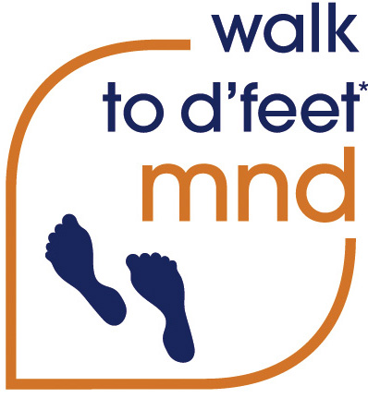Looking Forward To Seeing You There.

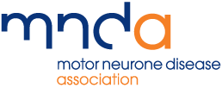

**Oxfordshire Branch MND Association**

**Sponsored Walk (2 miles or 5 miles)**

Blenheim Palace Park grounds, OX20 1PP

**Saturday 7th October 2023**

Registration from 11:30am

The walk will set off promptly at 1pm



Motor Neurone Disease Association | PO Box 246, Northampton NN1 2PR

Tel: 01604 611860 | Email: [fundraising@mndassociation.org](mailto:fundraising@mndassociation.org)

Website: www.mndassociation.org | Registered Charity No 294354

**Walker Registration Form**

If you have received this form via email or the web please print, complete, scan/print, and return by email to [Jill.Garner@outlook.com](mailto:Jill.Garner@outlook.com) Or complete the form in post to Jill Garner, 29 Queensway Didcot Oxfordshire OX11 8LY - by 25th September 2023. (Your form will be forwarded to National Office after the walk)

**YOUR DETAILS (Please use block capitals)**

First name: ……………………………………………… Surname: …………………………………………………………………..

Address: ……………… …………………………………………………………………………………………………………………………………………

County: ……………………………………………………. Postcode: ……………………………………………………………...

Tel no: ………………………………………E:mail address: ……………………

**REGISTRATION: £12 per adult (inc. t-shirt *subject to availability)** If you already have a T-Shirt please feel free to wear this to minimise contact when collecting a new one on the day.

**Cheques should be made payable to: MNDA Oxfordshire Branch**

T Shirt No. Small……………………Med…………………… Large……………………XL……………………

Number of Adults Walking: ……… Number of Children Walking (under 18): …….

Please provide the names of all walkers (Children under 14 must be accompanied):

………………………………………………………………………………………………………………………………………………………………………………

Number of walkers: ……… for 5 mile walk ……… for 2 mile walk

**EMERGENCY CONTACT DETAILS: Someone who is not joining you for the walk**

Name: ……………………………………………… Relationship: ……………………………………………

Mobile number: ………………………………………………

**Signature:** ………………………………………………………………… …………………

I confirm that all the information I have provided is true to the best of my knowledge and all donations raised on behalf of the MND Association Branch will be sent within 4 weeks of the walk.



**Walker Frequently Asked Questions**

**What do I need to do BEFORE the walk?**

• Complete the “Walker Registration Form” and return with Cheque (to avoid the handling of money on the day) alternatively visit:

[www.justgiving.com/](http://www.justgiving.com/)page/oxfordshire-branch-walk-2dfeet-2023

and donate your payment via this page – please ensure you include your Name in the Message Box and clarify if it is payment or a donation.

* Please **NOTE** that JustGiving will ask you to make a ‘Voluntary Contribution’, you can change this to ‘zero %’ if you would prefer not to.

• Encourage family, friends and colleagues to join you, and/or sponsor you. Sponsor forms available on request and on the MND Oxfordshire Web Pages

**What do I need to do ON THE DAY of the walk?**

• Wear suitable clothing and footwear.

• Arrive before 12:30pm, early, giving yourself time to meet everyone and register

• Read the Walkers’ Information and Public Liability Insurance Notice

• Sign the Walkers’ Registration Form to confirm you are in good health and fit enough to take part – only one person from each group needs to go to the registration table.

**What do I need to do AFTER the walk?**

• Please collect your sponsorship money and return to : **Roger Payne, 33, Glynswood, Chinnor, OX39 4JE.**

**Am I covered by any INSURANCE?**

• Participation in the walk is entirely at your own risk. To be covered under the MND Association’s public liability insurance (against third party damage only), you must sign the Walkers’ Registration Form on the day of the walk to confirm you are in good health and fit enough to take part. This does not cover you or your dependents for personal injury or death. Should you wish to be covered for personal injury insurance, we strongly recommend you take out your own insurance cover for personal accident benefits. If in doubt, please seek independent advice.

Thank you so much for your support.