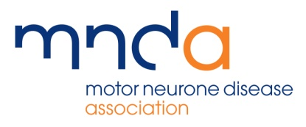

INTERNAL LOTTERY RETURN
Must be completed by MND Association Branch or Group
when it has been agreed that MNDA gambling licenses can be used
To be returned to Shabz Khokhar by email - shabz.khokhar@mndassociation.org

Branch/Group
&
Name of Organiser
Branded - Yes/No
Lottery end date
Lottery type
e.g., raffle style
Ticket cost (£)
Ticket sales non-remote (offline)
Ticket sales remote (online)
Total ticket sales
Amount (£) of proceeds applied to the purpose of the society (= total less the expenses & prizes)
Expenses (total value £) (please note this does not include any salaries of staff involved in running the lottery, or prizes which are listed separately below)
Prizes (total value £)
Largest prize awarded
(1st prize)
Amount rolled over to next lottery
Prizes from rollover
Date of next lottery

