
Branch and Group Editor Guide

Contents
Logging into Drupal 1
Resetting your password 2
Logging out of Drupal 2
Changing your login details 3
Navigation 3
Finding your branch/group page 3
How to edit my branch/group page 5
How to add a branch/group event 6
Using the branch/group map 7
APPENDIX: ADDING COMPONENTS USER GUIDE 8

Logging into Drupal
- For the new website, go to mndassociation.org/user/login
- Enter your username and password and then click ‘Log in’.
  - Your username will be your firstname.surname and your password will be set as Change.me1? which you will need to change on your first login.
- You are now logged in and can edit the site
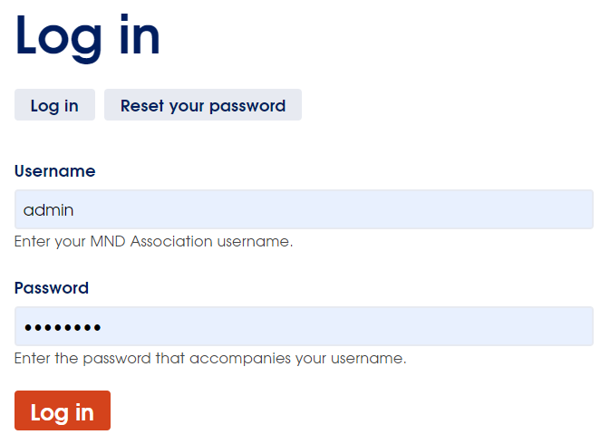

Resetting your password
- On the log in screen, click on the ‘Reset your password’ button
- Enter your username or email address and then click ‘Submit’
- Password reset instructions will be sent to your registered email address.
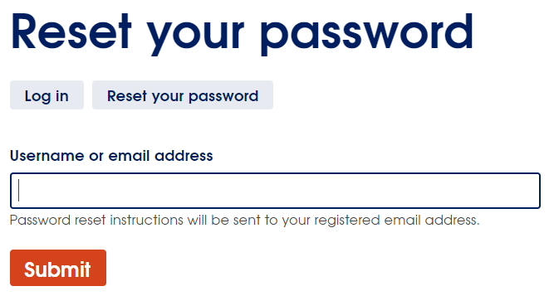

Logging out of Drupal
- Click on your name in the top left (shown as admin in this example)
- Select ‘Log out’
- You are now logged out
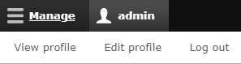

Changing your login details
- To change your log in details, select the ‘Edit profile’ link
- From here, you can change your username and password.
  - We recommend your username should follow the format of firstname.lastname
- Click the ‘Save’ button
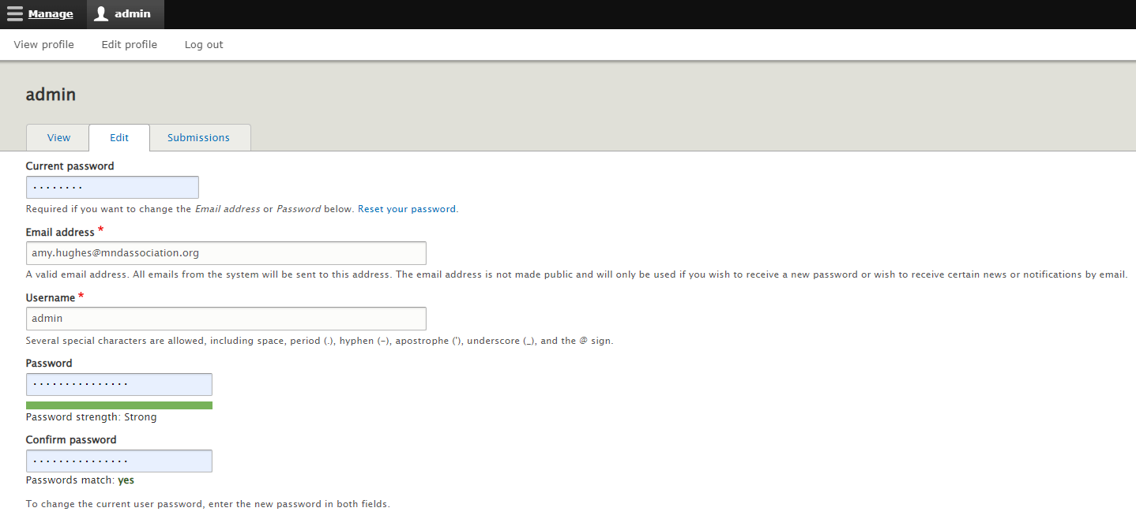

Navigation
When logged in, you can use the toolbar at the top of the screen to navigate through the backend of the Drupal CMS.
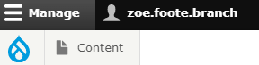
The main areas for content editors to be aware of are:
Content
Here is where you can go to:
- add new content
- find existing content and pages
- upload files and media
- or visit the media library.

Finding your branch/group page
- Once logged in, to find your branch/group page, go to Content in the toolbar and click Content.
- You will then see a screen showing content pages on the website. You will only have access to edit branch/group pages and events.
- Change the “Content type” filter to “Branch” and press “Filter” underneath to apply the filter.
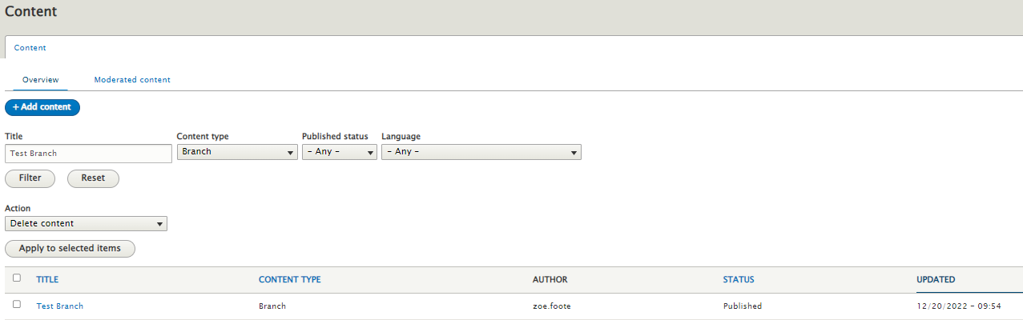
- You can now see a list of branch/group pages in the Drupal CMS.
- You can then use the Title field in the filters to search by the name of your branch, make sure you press filter for the search to be performed.
- To edit your branch/group page, click on the name of the branch/group in the Title column. This will load a preview of the page on the front end. You can then click on the edit button.


How to edit my branch/group page
- Once you have found your branch/group page using the steps above. Click edit. You will then be taken to this screen:
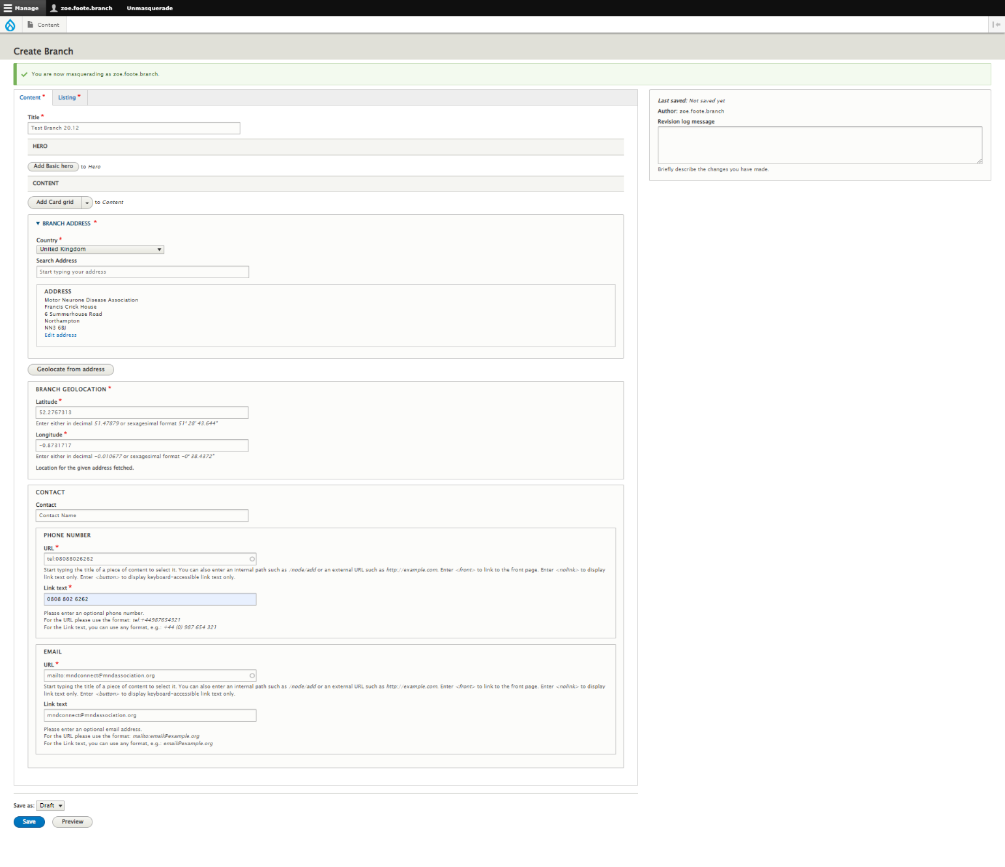
- The information will already be populated with the information from page set-up and how the information was displayed on the old MND Association website.
- If you wish to add more content, use this drop-down menu to add in the different components:
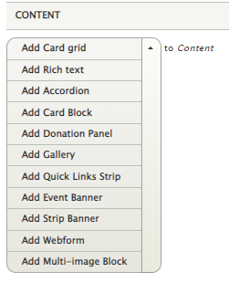
- To find out more about how to use these blocks, use the Adding Components User Guide, which is at the bottom of this document.
N.B. Not all components will be relevant for branch and group pages, so instructions have only been included for components you should need.

How to add a branch/group event
- Go to Content > Add Content > Branch Event
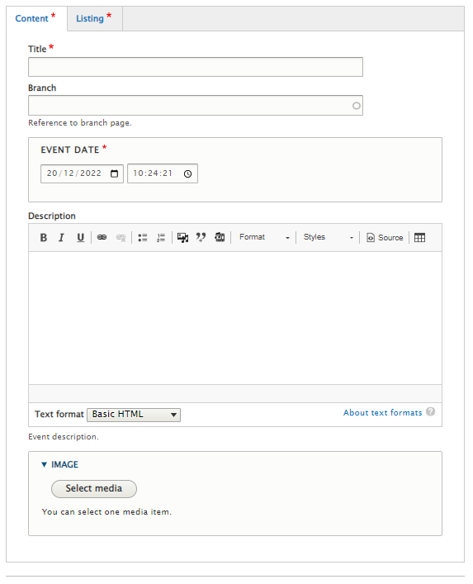
- You can then add:
  - Event Title
  - Connect the event to the branch/group by typing the branch/group name in the “Branch” field. Select the correct branch/group from the list.
  - Event Date and time.
  - Description for the event. You can format the text in this field as you wish. Instructions on how to do this are included in the appendix under the ‘Rich text’ component.
  - Image – if there is an image that you would like to use to promote the event, click on ‘Select media’. Find the relevant folder for your branch or group and then select ‘Add media’ and choose the image you would like to upload. You will need to include alternative text on this image which will be used by screen readers, search engines or when the image cannot be loaded. This should be a description of what the image shows.
If no image is selected then a default image will be used which shows a blue icon – so this is not a problem if you do not have an image for the event.
- On the Listing tab, you will need to add:
  - Featured text: This is the text that will be displayed as a preview of the event if someone uses the site search and this event shows as a result. It needs to be a short preview of the page i.e., “This is XXX event being run by XXX branch/group”.
  - Search weight: This gives the page a search weighting to see how important it is compared to other results in a search. 2 is the default weight, so is suggested if you are unsure.
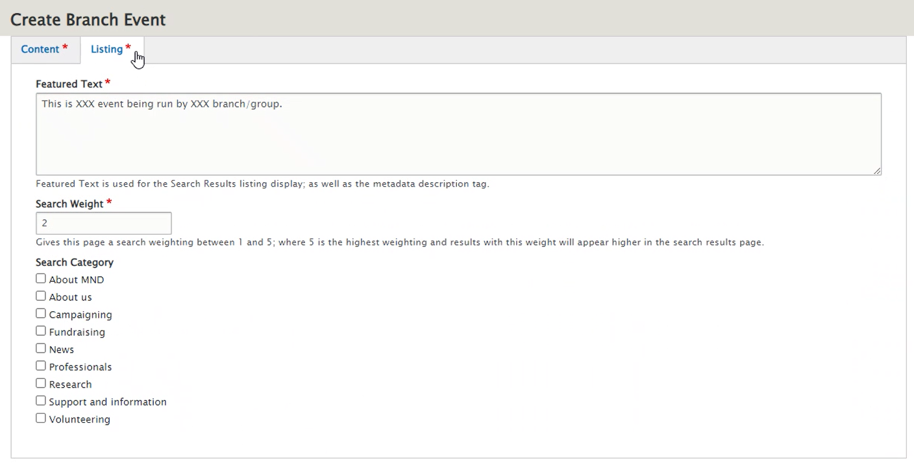
- You will then need to press save at the bottom of the page, which sends a notification through to MND Association staff who will review and press publish on the event if there are no issues.

Adding additional branch/group pages
If you require additional pages setting up for your branch/group, please contact the Digital team who can set these up for you.

Using the branch/group map
- You can see the branch/group search here: https://live-mnd-association-drupal.pantheonsite.io/branch-search
- You can either use this in list view or map view. To change the view, toggle between the list icon and map icon on the right-hand side under the filters.

APPENDIX: ADDING COMPONENTS USER GUIDE
Contents
Add Basic hero 9
Rich Text Component 12
Add Card Grid 16
Add an Accordion 19
Add Gallery 20
Add Card Block 22
Add Stats 23
Add Quick Links Strip 25
Add Strip Banner 25
Multi-image block 26

Add Basic hero
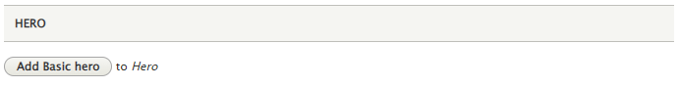
- Click Add Basic hero.
- The panel will then expand and show:
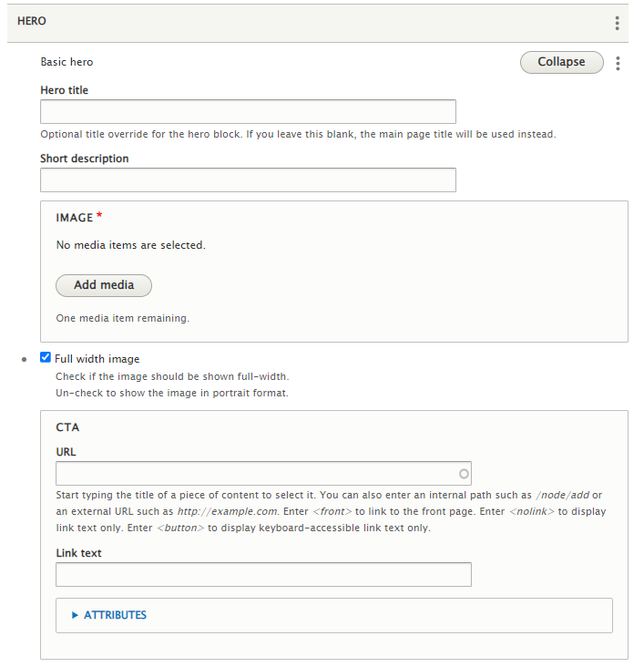
- Add:
  - Hero title (optional)
  - Short description (optional)
  - Image – mandatory.
    - Click Add media
      - This will pop up with an image library. You can either select an image from the images already uploaded, or “Choose File” to upload a new image.
      - Then click Insert selected.
      - Here is some support as how to write good Alt Text to describe images: https://accessibility.huit.harvard.edu/describe-content-images
  - You can then choose if the image is shown as full width or a smaller portrait sized image with a blue background.
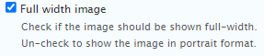
  - Best practice is that images shouldn’t have any text in them for accessibility reasons.
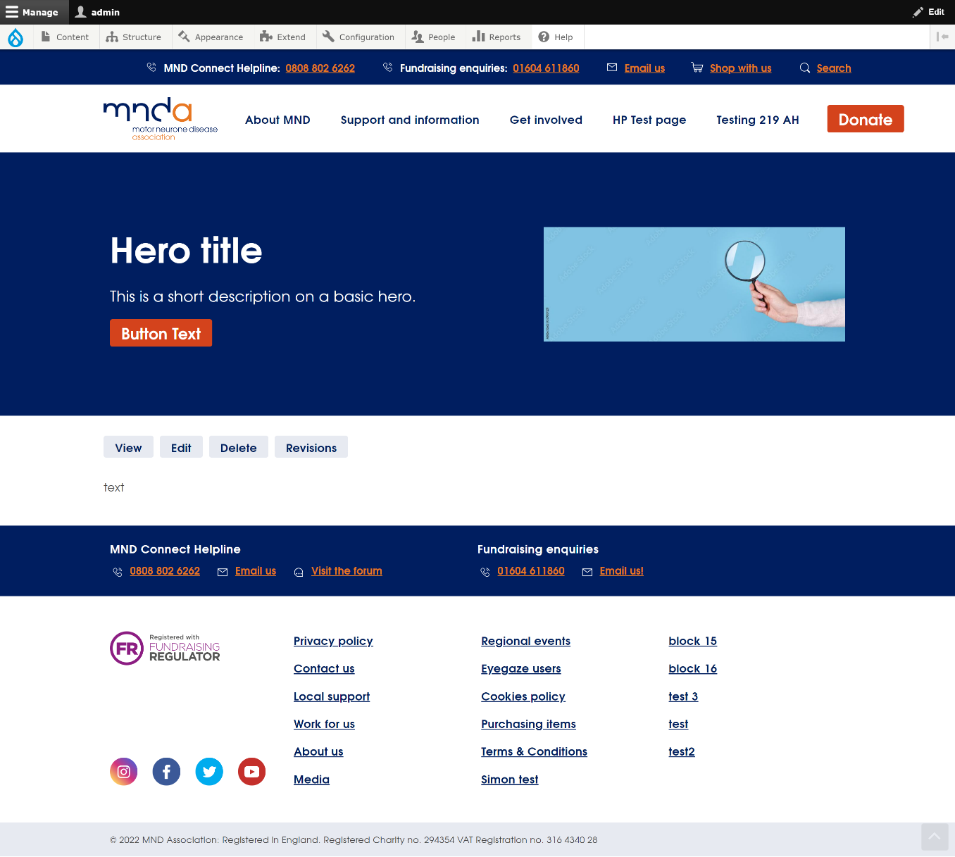
Example in portrait format:

  - CTA button:
    - URL: Add the URL that you wish the CTA button to go to.
    - Link text: This is the text that will display in the CTA button, e.g. “Button Text”
    - Attributes: This allows you to select whether the link opens in the same tab, or in a new tab.
      - Best practice is that only external links, i.e. links not going to our website, should open in a new tab.
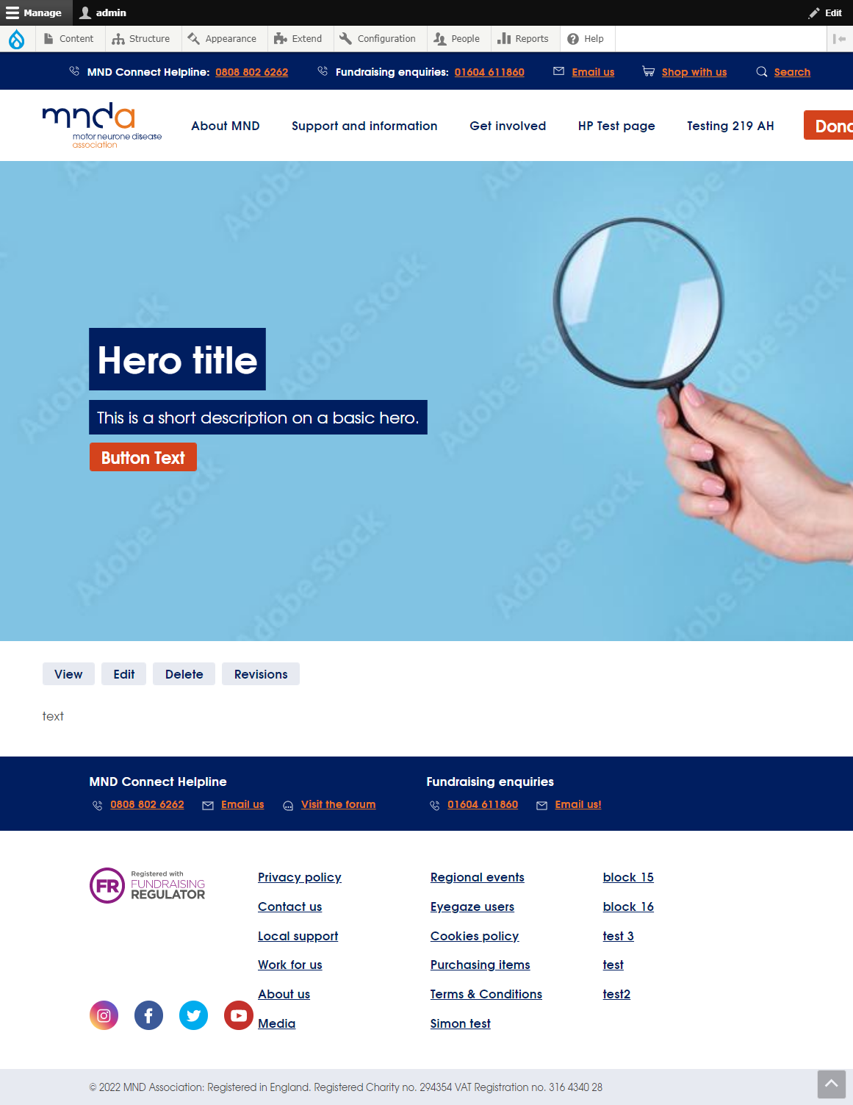

Rich Text Component
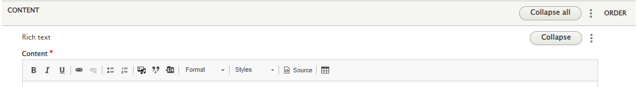
- A rich text component allows you to free write text content to appear on pages. There are several options for text formatting, and you can also add in images, videos and links within a rich text component.
- This component may also be referred to as a WYSIWYG (What You See Is What You Get).
- Options from left to right across the top of the component:
  - Bold
  - Italic
  - Link: Highlight the text you want to hyperlink and click the link button.
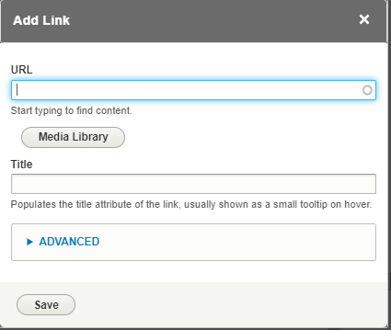
    - URL – add in the URL you wish to link to.
    - Media Library – this allows you to select to link directly to a file from the media library. The below pop-up box will appear:
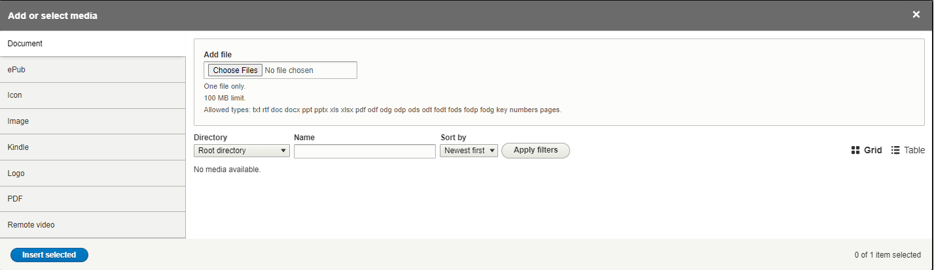
Select PDF down the left hand-side, and this will show PDFs already uploaded into the media library. You can use the ‘Directory’ filter to choose the folder you want to view, then press Apply filters to see results in that folder. Select the relevant PDF and click Insert selected.
    - Title – This populates the title of the link, shown when you hover over the link.
    - Advanced – Only option you should need is:
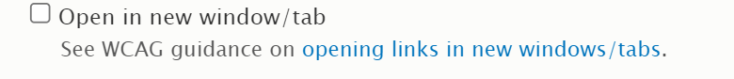
      - This allows you to choose whether the link opens in the same tab or different.
    - Once you have done the above steps and your link is created, if you wanted this to appear as a button, you can then re-highlight the text and select the “Styles” dropdown across the top.
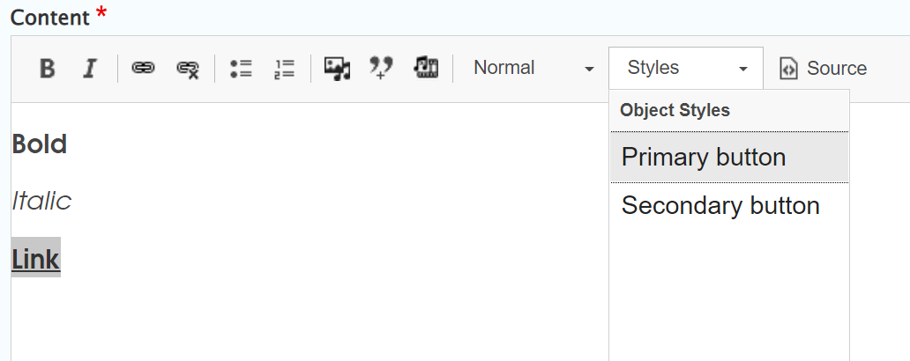

      - This allows you to select either a primary button or secondary button depending on the emphasis you want to place on the call to action.
  - Remove Link: If you wish to remove a hyperlink from text, then re-highlight the text and click the remove link button.
  - Insert/Remove Bulleted List: This allows you to format a list with bullet points.
  - Insert/Remove Numbered List: This allows you to format a list with numbers.
  - Insert from Media Library: Click this and a pop-up of “Add or select media” will appear. You can either select an image from the images already uploaded, or “Choose File” to upload a new image.
    - Then click Insert selected.
    - You can then edit the media once it is in the rich text component:
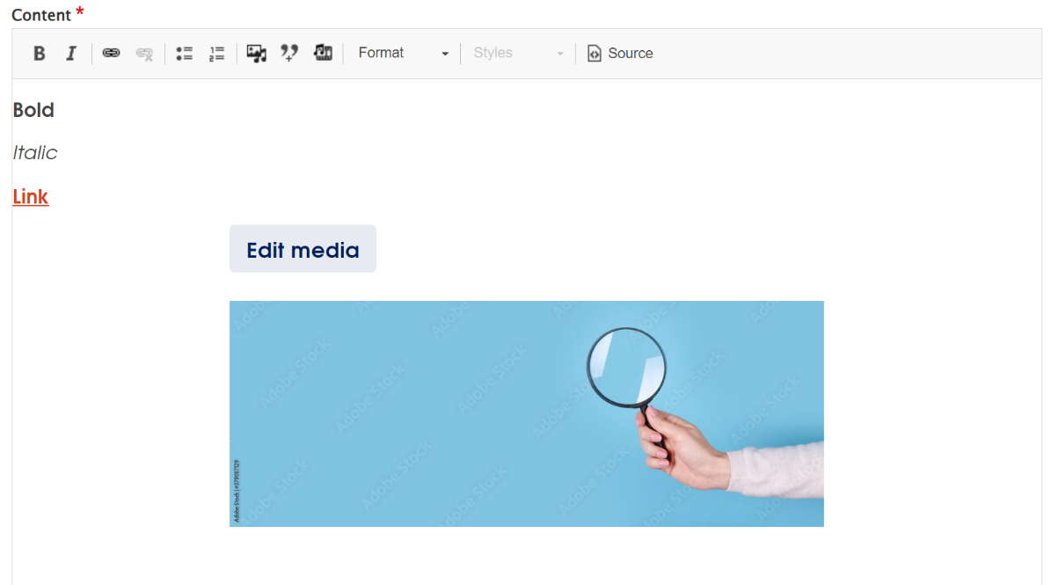

    - If you click “Edit media” then a pop-up appears where you can add in the alternate text, which provides a short description of the image for those using technology such as screen readers. You can also choose the alignment of the image e.g., left or centred.
      - Image Size options:
        - The left or right alignment option show the image to up to 50% width, (half the rich text column). This is so the text doesn't get squashed down too much that it becomes illegible.
        - To show a larger image, the 'None' (no alignment) option can be used, which will display the image the full width of the column.
        - Otherwise, the centre option can be used to centre the image within the text and is shown at around 75% of the column width.
  - Insert Quote: Clicking this then brings up a pop-up box which asks you for the quote text and the quote author.

    - This then appears in a formatted way as shown in the screenshot above.
  - Embedding a video: Clicking this then brings up a pop-up with a URL option. Enter the URL of the video, e.g., YouTube to embed a video.
  - Format: This allows you to format text differently, in just normal paragraph style or in heading styles etc.
  - Tables
    - In the table properties overlay, enter the number of Rows and Columns; and set "Headers" to be "First Row"
    - In the "Full HTML" format, you can specify the table width. This is defaulted to 500; clear this value so the table spans the full width of the page.
    - In the first row of the table, type in the headers for each row, then populate the rest of the table.
    - You can change the font style, making text bold, italics, etc; as you would normally
    - You can create an inline link by selected the text to turn into a link, and clicking the "link" icon. Add a title and a URL.
    - You can create a primary button, by following the same steps as the inline link process, but then selecting "Primary Button" under the "Styles" dropdown.
    - If you need to edit a table that already exists (adding a new row, etc), in the WYSIWYG editor, right click on the table to open a popup with options to edit the table layout.
- Example of the rich text component when published:
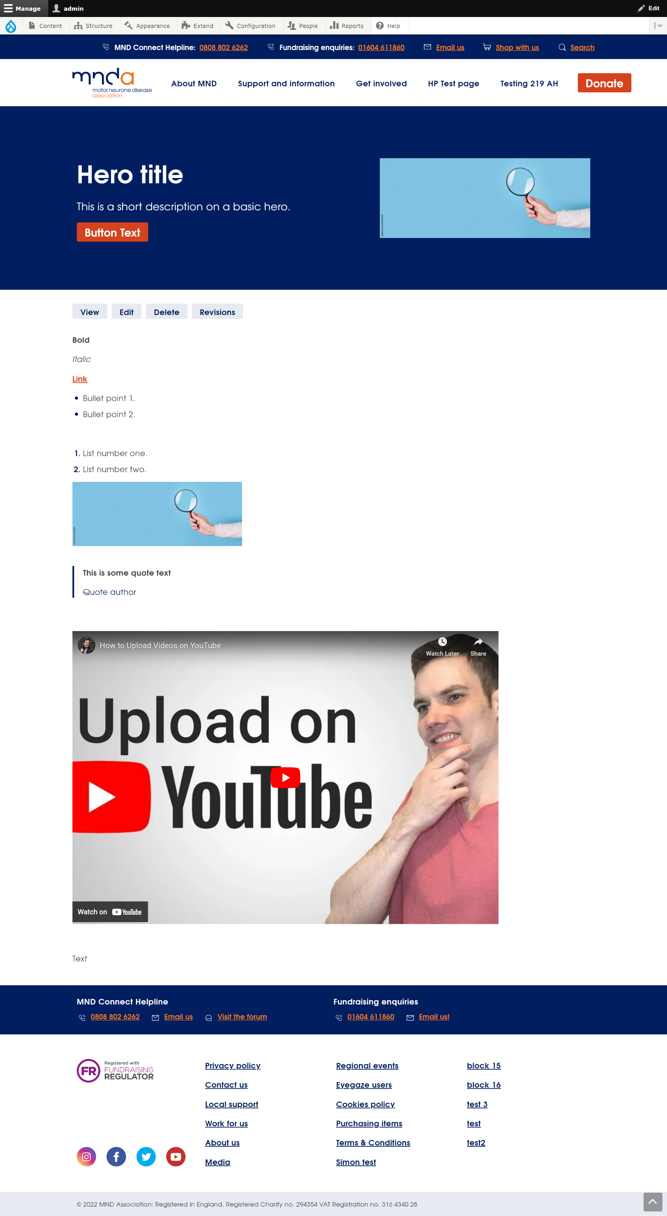

Add Card Grid
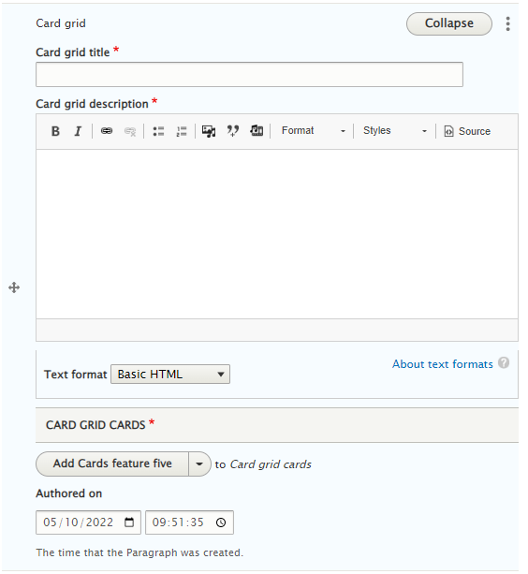
- Add a Card Grid title.
- Add a Card Grid description.
- Choose from the ‘Card Grid Cards’ drop-down.
  - Add cards feature five.
    - This then brings up five sections – one for each card. You will need to provide a URL, the link text and an image for each card.
      - N.B. the first two images show down the left-hand side as larger images and the final three images show down the right-hand side as smaller images (see in screenshot below).
      - You can also choose in the ‘Attributes’ section whether the link from the card should open in the same tab or a new tab.
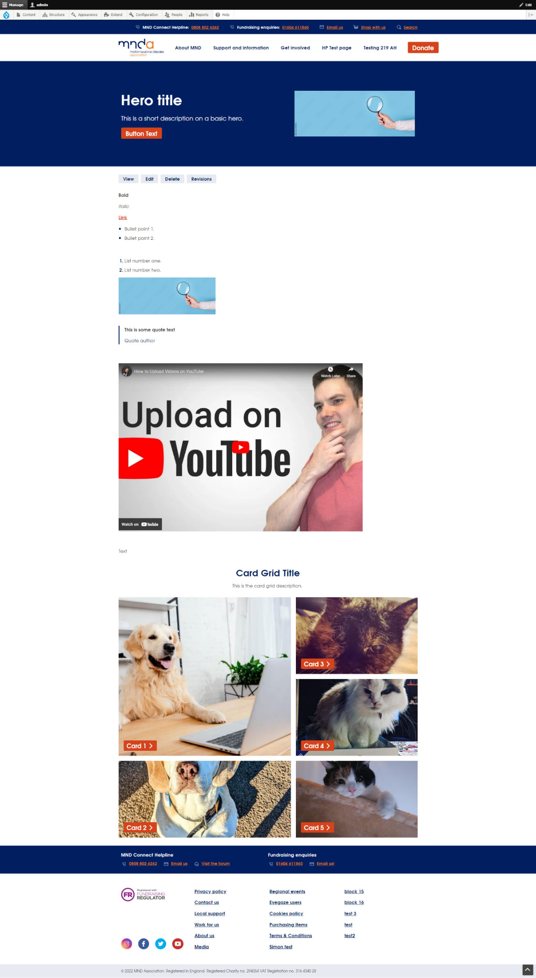

  - You can also choose to add additional rows to the card grid by selecting ‘add cards row’. This brings up three more sections to add an additional three cards. Cards 1 and 2 in this additional row are mandatory and the third card is optional – this can be removed by clicking the three dots in the top right-hand corner of the section.
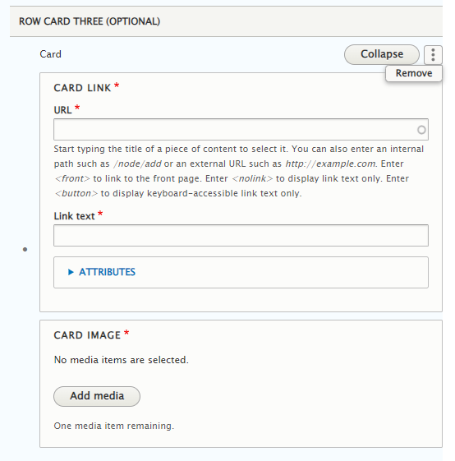
- There are now also additional options for card grids without images:
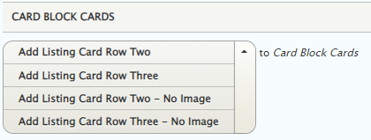
Simply select, "Listing Card Row Two - No Image" or "Listing Card Row Three - No Image" and follow the same steps as above without having to add an image.

    - Below is an example of the card grid with additional cards.
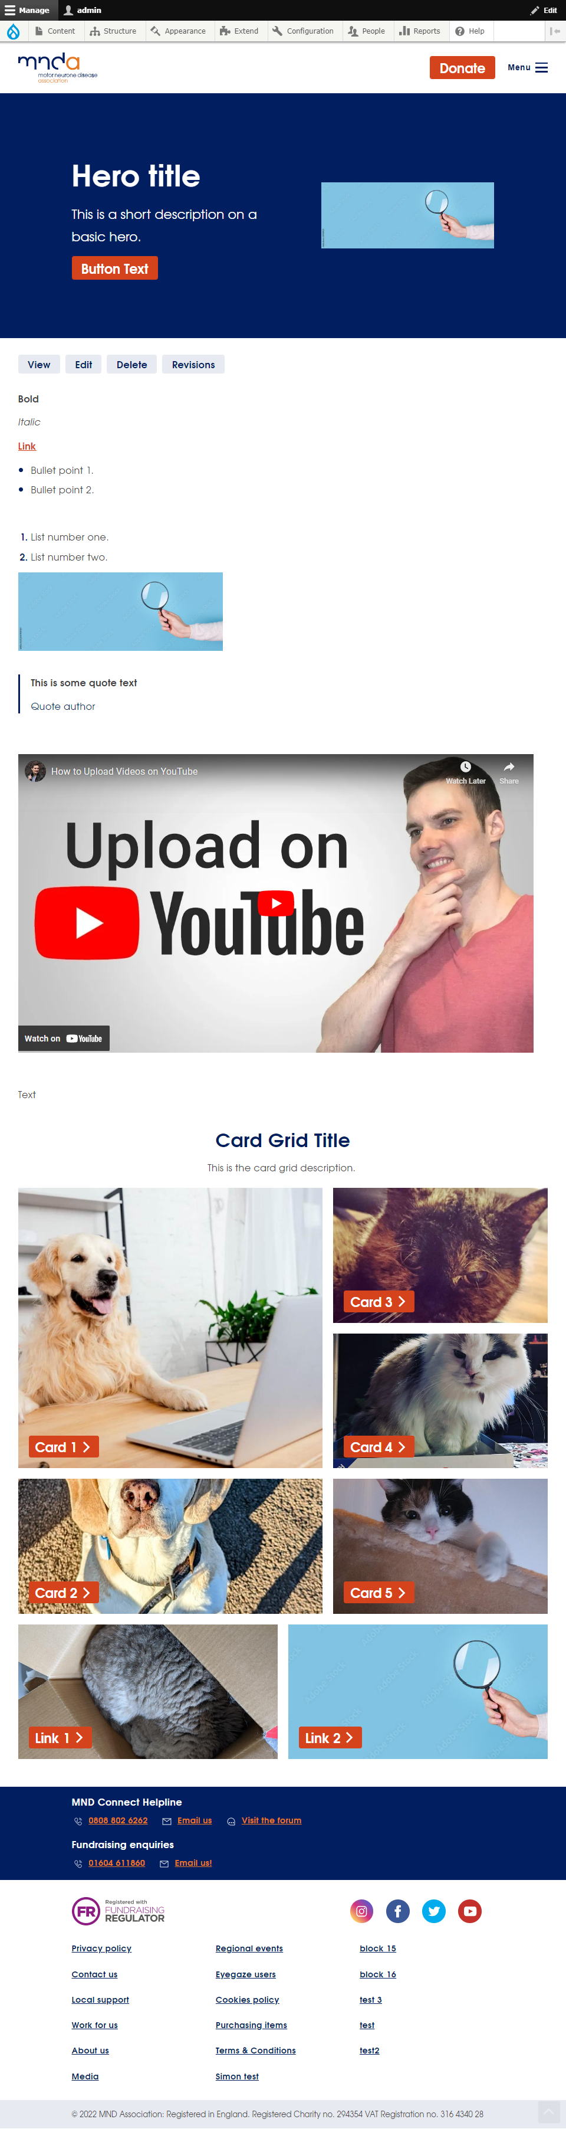

Add an Accordion
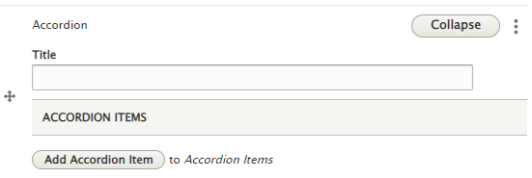
- Adding an Accordion shows the above view.
- Then click ‘Add Accordion item’
  - This allows you to input a title for the Accordion and also the content for within the Accordion using a rich text editor.
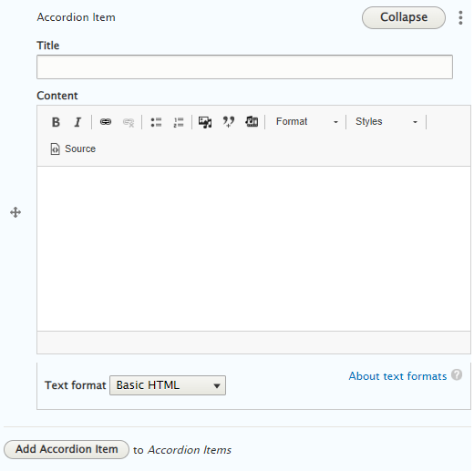
  - You can add multiple accordions using the ‘add accordion’ selection.
  - You can also change the order of the accordions by using the drag and drop function down the left-hand side of the above screenshot.
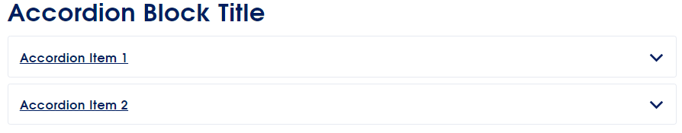
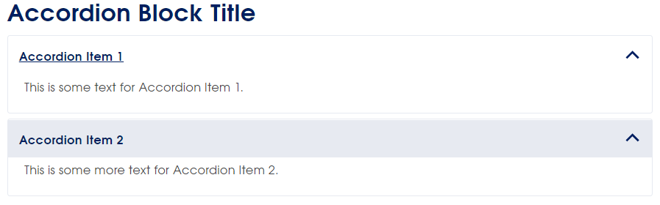

Add Gallery
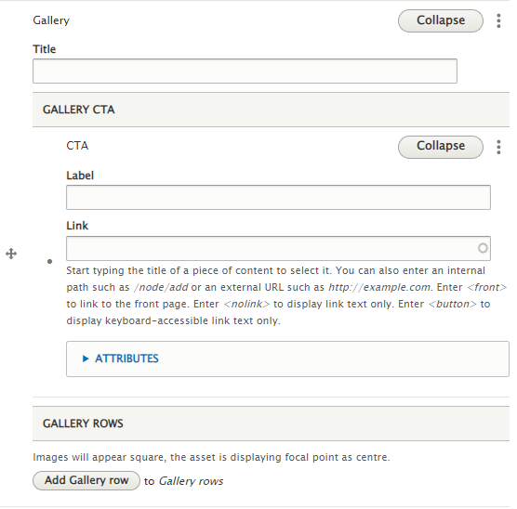
- Add a Title (optional).
- Add a CTA (optional) – this includes a label and the link. ‘Attributes’ allows you to choose if the link opens in the same tab or a new tab.
- Click ‘Add Gallery row’
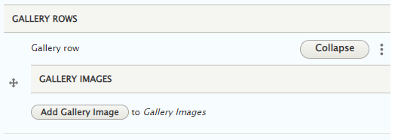
  - Click ‘Add Gallery row’
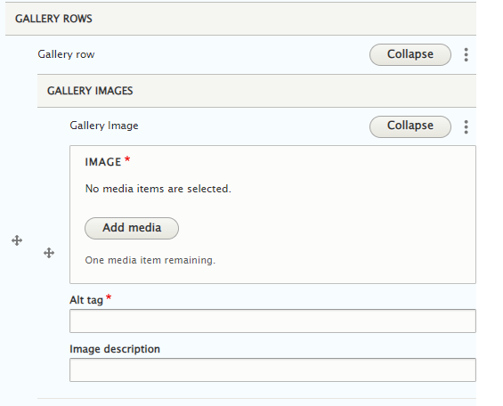
  - The above screenshot shows what then appears.
    - Click ‘add media’ and select the image from the gallery or upload an image.
    - Complete the ‘alt tag’ (see best practice guide for images for further support).
    - You can also add an optional image description.
  - You can then click ‘Add gallery image’ to add multiple images to the gallery.
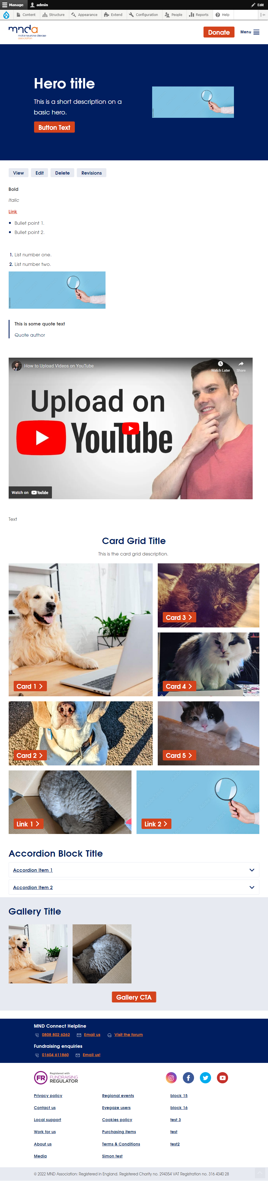

Add Card Block
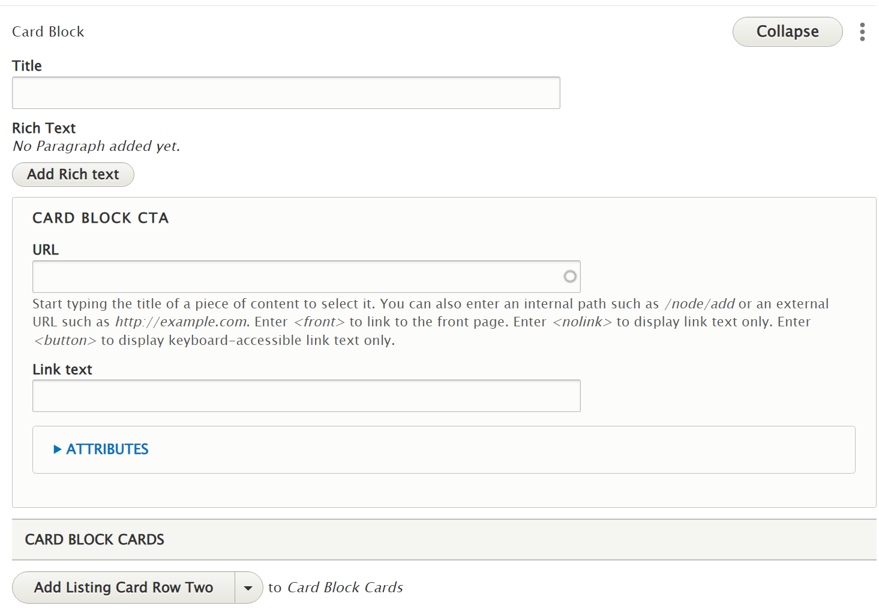
- Add a Title (optional).
- Add Rick Text (optional).
- Add the URL you want to link to from the Card Block.
- Add the Link text to display on the CTA button.
  - ‘Attributes’ allows you to choose if the link opens in the same tab or a new tab.
- Choose either ‘Add Listing Card Row Two’ (which has two cards) or ‘Add Listing Card Row Three’ (which has three cards).
  - Add Listing Card Title to each card.
  - Add Listing Card Description to each card.
  - Add an image or icon to each card.
  - Add a CTA (optional) – this includes a label and the link. ‘Attributes’ allows you to choose if the link opens in the same tab or a new tab.
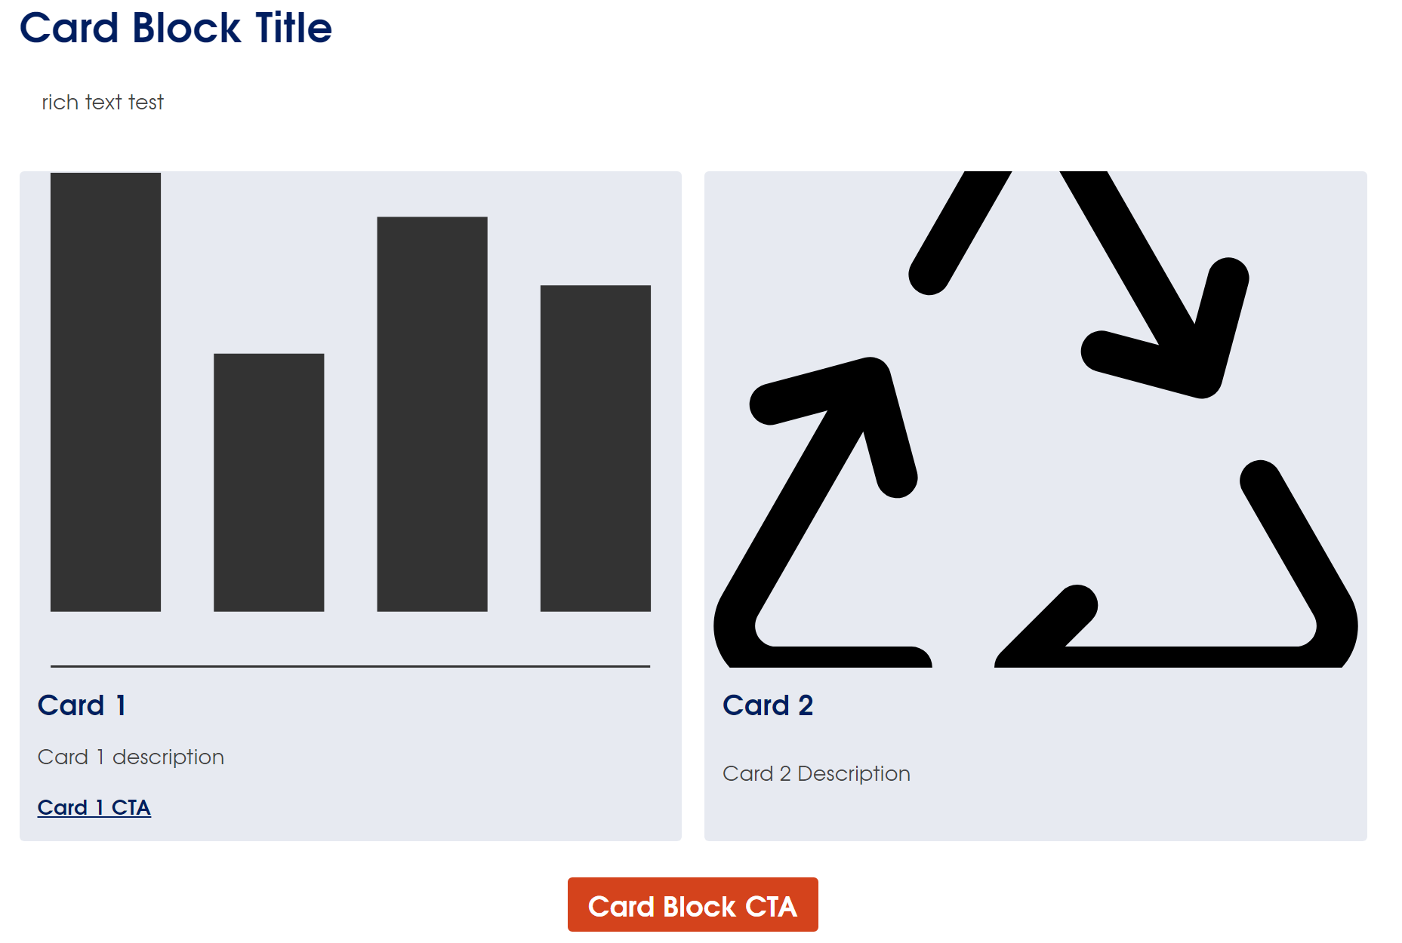

Add Stats
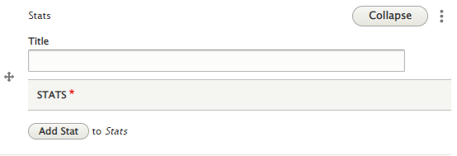
- Add an optional Title for the Stats component.
- Click ‘Add Stat’.
  - Below is what shows:
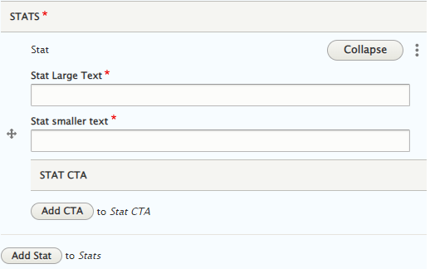
  - Stat Large Text: This is the key piece on information for your stat, it can either be a number or text.
  - Stat Smaller Text: This is the descriptive section for your stat. It can either be numbers or text.
  - You can add a CTA to the stat by clicking ‘Add CTA’. You can add the CTA Label and Link.
  - In ‘Attributes’ you can decide whether you want the link to open in the same tab or a new tab.
- You can add multiple stats by clicking ‘Add Stat’.
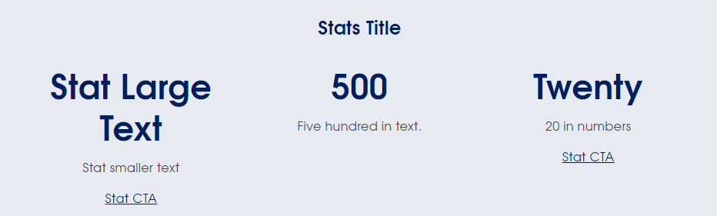

Add Quick Links Strip
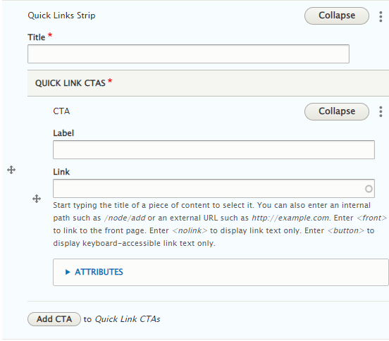
- Add a Title.
- Add a CTA – both label and link.
  - In ‘Attributes’ you can decide whether you want the link to open in the same tab or a new tab.
- You can add additional quick links by clicking ‘Add CTA’ to Quick Link CTAs.
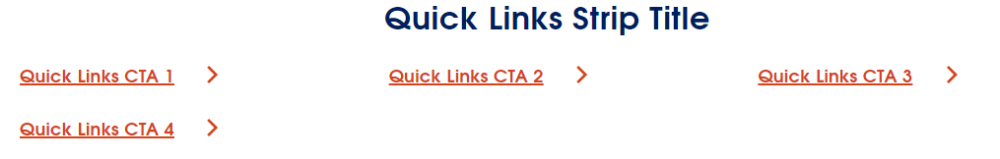

Add Strip Banner
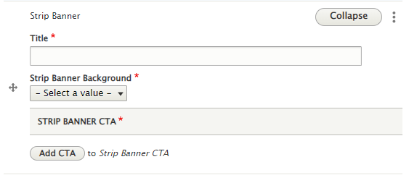
- Add a Strip Banner Title.
- Use ‘Strip Banner Background’ to choose the correct brand colour for the strip banner.
- Click ‘Add CTA’ and add the label and link for the strip banner. ‘Attributes’ means you can choose whether the link opens in the current tab or a new tab.
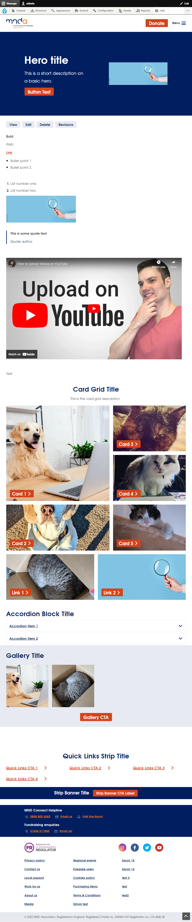

Multi-image block
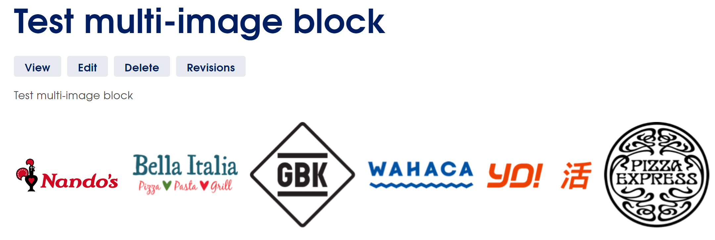
- Images can be seen side by side.
- You should use a minimum of 2 images and a maximum of 6.
- The images can be linked and the link will open in a new tab.

