AGM OF THE APPG on MOTOR NEURONE DISEASE
14:00-15:00 on Wednesday 13 March 2024
MPs present:
Andrew Lewer MBE MP
Justin Madders MP
Christine Jardine MP
Liz Twist MP
Peter Aldous MP
Steve Tuckwell MP
Richard Fuller MP
Louie French MP
Yvette Cooper MP
Alberto Costa MP
Lia Nici MP
Sir Oliver Heald MP
Gavin Williamson MP
Mickey Brady MP
Francie Molloy MP
Peers present:
Baroness Finlay
Lord Bethel
Lord Bellingham
Others:
Office of Lord Alf Dubs represented
Office of Sir Desmond Swayne MP represented
Nick Cole, Head of Research, MND Association
James Smith
MND Association Secretariat
Apologies:
Baroness Hollins
Lord Foulkes
Baroness Cox
Caroline Noakes MP
Ben Spencer MP
Andrew Western MP
Sir Lindsay Hoyle MP
Nickie Aiken MP
Rachael Maskell MP
Rt Hon Jeremy Quin KC MP
Munira Wilson MP
Stephen Timms MP
Danny Kruger MP
Nick Thomas-Symonds MP

- Welcome and Introductions
Andrew Lewer MBE MP welcomed colleagues to the meeting. He outlined he would proceed with the formalities of the AGM before inviting the guest speakers to address the group.

- AGM
The following Officers were elected to the APPG:
- Chair – Andrew Lewer MBE MP (seconded by Richard Fuller MP)
- Officers – Mary Robinson MP, Ian Byrne MP and Brendan Clarke-Smith MP (seconded by Alberto Costa MP)
Confirmed the membership list as of 13th March stands at 30 MPs and Peers.
The MND Association was re-appointed as the Secretariat to the Group.
It was confirmed that the financial contribution to the APPG does not exceed the sum of £1,500.
- ‘My life with MND’ - James Smith
James Smith, a young father living with MND began by offering MPs a “once in a lifetime opportunity to join a club.’ This club, he outlined, has a membership which:
“normally expires in 2-5 years for most. You end up not being able to work and earn money to provide for yourself and your family. You will also need to rely on others to help you maintain being a member of this club and overtime, for some very quick and for some very slow, lose the ability to do simple day-to- day tasks and activities. Being a member of this club, you will start to find your muscles and strength is affected and every day you will become weaker and weaker to the point you cannot do anything for yourself and to top that off you have no medical treatment to help.
James highlighted this ‘club’ is what 6000 people at any one time in the UK are a part of; the MND community. Previously a keen runner, James spoke to the group about the first symptoms of MND he experienced, including persistent twitching in his left arm which then progressed to weakness.
He spoke about the longtime it took to be ‘officially’ diagnosed with MND, being passed between three different neurologists, and undergoing many painful tests all whilst Covid lockdowns were occurring. Whilst he waited for his diagnosis to be confirmed, James’ wife was expecting their third child.
Once he was finally diagnosed, although James was told he had a ‘slow progressing’ version of MND, he was advised to complete any bucket list items by the age of 40. At the time he was just 36 years old.
James spoke about the challenges he had experienced in accessing trials for MND treatments since this diagnosis, despite being told researchers would be “banging down” the door to have his participate. Having fought to get onto the MND SMART trial, the drug he was being trialed on was pulled after just six months. On the hunt for more drugs to trial James spoke about the frustration he felt in discovering that most trials wanted applicants to be in their first two years of symptoms rendering him ineligible.
He spoke with the group about the hope the top-line results the MIROCALS trial had provided for the MND community, but the frustration that is felt 15 months on from this announcement, with the full results not having yet been published, meaning limited progress has been made towards accessing this treatment for the wider MND community. He highlighted the inequality that is starting to occur with some within the MND community able to access the treatment privately, and the dangers if patients are reconstituting the treatment themselves.

James made clear how important hope is for the MND community, hope to fight back against the disease and have longer with loved ones.

- ‘Drug development and the regulatory landscape’ - Nick Cole, Head of Research at the MND Association
Nick then spoke to the group about how challenging a process drug development is as it requires huge collaboration between researchers, people living with and affected by MND, healthcare professionals, patient advocatory groups and regulatory authorities.
He outlined the nature of MND makes it difficult to develop drugs for, because as a neurodegenerative disease, it is hard ‘to see what is going on’. It is not like cancer where a part of a tumor could be removed to understand its biology, as a disease it is very heterogenous, with many different forms, and different progression rates.
Nick made clear however the UK is a key player in MND research, at forefront of drug discovery and innovation, reflected in the amount of pre-clinical work that is UK led and delivery of innovative trial designs like MND SMART which can test large numbers of drugs at a quicker rate. The third sector also plays its part in supporting and funding this work: MND Assoc, MND Scotland, My Name’5 Doddie, UKMNDRI, LifeArc all play a part.
Nick outlined that researchers are coming at MND from all angles and taking multiple approaches to identify new treatments – genetic therapies (tofersen), and interleukin 2 for sporadic MND.
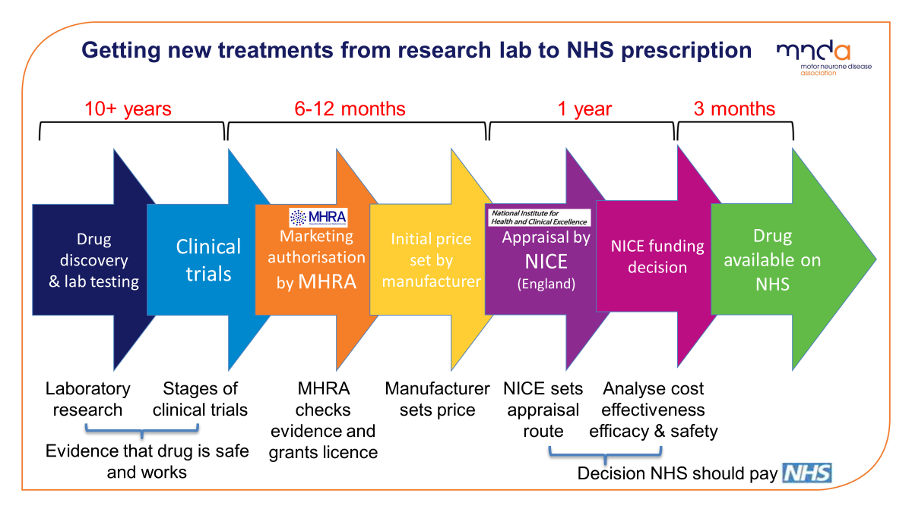
Nick then talked the group through Figure 1: Journey of treatments from research lab to NHS prescription:

- ‘Tofersen update’ - Alex Massey

- Discussion & questions
Fig. 1
To highlight the difficulties posed by this journey Nick raised the case of Tofersen - a treatment for people living with MND who have SOD1 gene mutation (2% of MND population have SOD1 gene change), which has been approved by the EMA and FDA.
He outlined that the route NICE have chosen to appraise this technology (the Standard Technology Appraisal programme rather than the highly specialized technology route) meant it was almost certain the manufacturer of this treatment will not proceed with the drug because it is not economically viable now.
5. Tofersen & NICE appraisal process - Alex Massey, Head of Campaigns, Policy and Public Affairs, MND Association
Alex Massey expanded on this highlighting the concern that had been caused because of how NICE has chosen to appraise Tofersen. A treatment which has been shown to have significant effects on disease progression and survivability.
He outlined this is a treatment targeted to a genetic subpopulation of the MND community, only around 60-80 people at any one time in the UK living with this form of MND. Treatments which are aimed at a population that small should go through the highly specialized route which essentially applies different cost / benefit criteria to ensure a treatment aimed at a very small population is not disadvantaged by miscalculations.
NICE has chosen not to do that with this treatment saying it does not regard the SOD1 gene group as clinically distinct from the MND community as a whole, despite the fact we have a treatment which works only for that set of the population and flies in face of clinical research experts evidence.
As a result, it is effectively impossible for Tofersen to demonstrate value through the standard process, even if the manufacturer (Biogen) were offering it for free to the NHS it would still not be evaluated as cost effective.
Alex outlined that this means despite the fact the trials on this treatment were conducted here, it is a UK research success story and a great example of precision medicine, patients in this country will not have access to it due to approach taken by regulators.
Concerningly it seems to:
- Potentially set a precedent that would put any other gene targeted treatment for minority of MND population in the same situation.
- Potentially shuts the door going forward for gene targeted treatments going forward - and this affects those treatments at large.
- Fly in the face in the Gov’s ambitions for use of genomics, personalized medicine, precision medicine - ambition set out in rare disease strategy. How does that square with this?

- Questions
Yvette Cooper MP asked about the situation with Interleukin 2 and why the results have still not yet been publicised, and asked if there was anything that could be done to speed up publication of results and what can MPs be doing in helping to support this.
Alex responded the MND Association understands and shares the frustration of patients at how long it has taken for the full publication of results from the MIROCALs trial.
He outlined however the Association also recognise this is an enormously complex study & there are many thousands of data points that need to be analysed to a standard which will pass review and stand up to scrutiny of regulators.
He clarified the Association has been in contact with the research team conducting this analysis, who have confirmed the data hasn’t been published yet because it isn’t ready, but as soon as it is, it will be. The Association has offered support to this team, and whilst this hasn’t been taken up, they stand ready to help as would be useful.
Alex outlined the Association has been informed it shouldn’t be too much longer until the full results are released. In the interim, the Association alongside other charities (My Name’5 Doddie, MND Scotland) have written to the MHRA to inform them of this and ask they be fully prepared to move ahead with access programmes for people living with MND as quickly as possible when the results are released, assuming they are positive. The Association also met with NHS repurposing scheme & prepared materials so that clinicians will be supported to make applications on a named patient basis to gain access.
MND Association latest update on this issue can be found here.

Lord Bellingham - asked about what was the state of international collaboration on MND research, and whether there was a link between sport and MND given the number of high profile sports players who have diagnosed with the disease.
Nick Cole responded that the international research community are very collaborative in sharing information and findings, which is reflected in the international symposium on MND which takes place every year, bringing together over 1000 research professionals.
On the causes of MND he outlined that lots of studies have tried to find the links between sports and those diagnosed with MND but it has never been proven, despite anecdotal evidence from clinicians and those who are diagnosed. He spoke about an international project looking into the causes of MND: Project MinE which has identified 40 different genes associated with MND.

Peter Aldous MP asked a follow up question to clarify the correlation between sports and MND
Nick outlined again there no firm evidence that sport and exercise cause MND, and that the correlation is not necessarily causation. He spoke about how researchers just did not know if body type, which might people better at sport might mean people can be more susceptible to getting MND, and there is a lot science still does not know about MND.
Emma McLellan (on behalf of Lord Dubs) asked the group about NICE’s recent decision on Tofersen.
Nicola McFarlane on behalf of Patients United Against MND informed Members that for updates on what has been going on with MIROCALS they could look at Patients United against MND.
Dave Setters on behalf of the UKMNDRI asked Members to acquaint themselves with the MIROCALs situation as the more people who are prepared, valuable time will be saved. He asked Members to be ready & be prepared to push local authorities to fund the drug on the confirmation of positive trial results. Highlighted MND specials could end up being a postcode lottery. Asked MPs to find out & get transparency on MIROCALs choice of commercial partner, and ability of that partner to deliver that drug to scale more quickly than already available drug proleukin.
Dr Ammar Al-Chalabi on behalf of the UKMNDRI outline as a member of the MIROCALs consortium they were what they could to influence the writing group, however he outlined what we can do is be prepared for speed once information is out into the public domain and potentially get access via NHS specials & named patient basis (he clarified he had started doing that process at kings for patients under his care and had shared with colleagues in other locations). He also outlined that in reference to Lord Bellingham’s question, international collaboration is the mainstay of what researchers into MND do, because although MND is not rare, given people don’t live very long people with the disease, the only way large enough numbers of people can be found to study what is going on with the disease is via international collaboration. He also encouraged Members to listen to this podcast he had just featured on with Gabby Logan to learn about MND in a ‘quick and chatty way.’

- AOB & future actions
Andrew Lewer MBE MP thanked colleagues for attending.
He outlined the secretariat will compile the minutes and circulate to colleagues for review and submit the formal requirements to the Whips Office for the AGM to be registered.
Future actions on issues raised on emerging treatments will be circulated to members in coming weeks.

