Event Incident Form

Date: | Location: | Type of Event:
Person affected: | Address: | Contact  Number:
Male  Female | Next of kin  Details: | Raiser’s Edge Number:

First aid treatment:

Yes No by whom:

Please circle the area/s of injury on the person below:
Description of incident/injury:

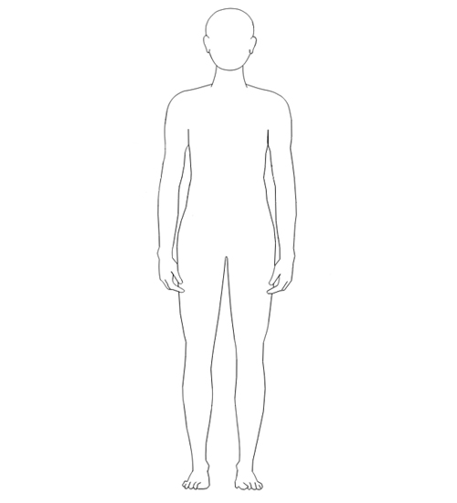

Please see overleaf

Contributing factors e.g. weather conditions, medical history:

Hospital Name if ambulance called:

Follow up information (call person affected 24 hours after incident):

Person affected
Name: | Date: | Signature:

Person Completing form
Name: | Date: | Signature:

The Facilities Management team should be informed of hospital treatment. Phil Day on 07718 393969 or Darren Carr on 01604 611815
Please return the completed form to a member of the Facilities Management team at MND Association, Francis Crick House, Summerhouse Road, Moulton, Northampton, NN3 6BJ or e-mail to Facilitiesreception@mndassociation.org

