How to set an automatic signature
This guide will show you how to set an automatic signature on your emails so that when you send and reply to emails all of the important information such as your name, role, contact details are automatically displayed at the bottom of your email.
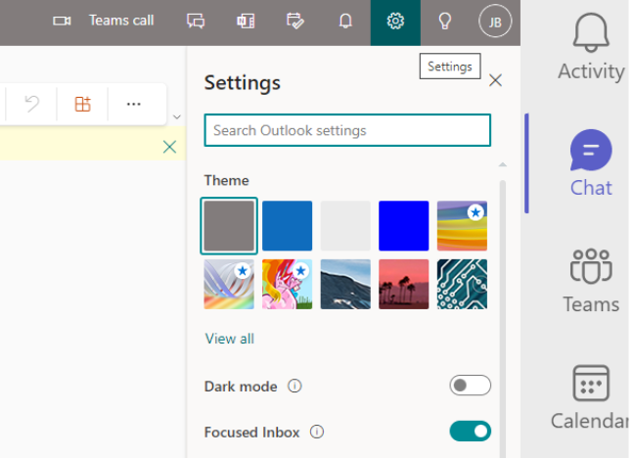

From the Outlook home page click on settings in the top right-hand corner of your page. Type the word ‘signature’ into the search box then click on Email signature.

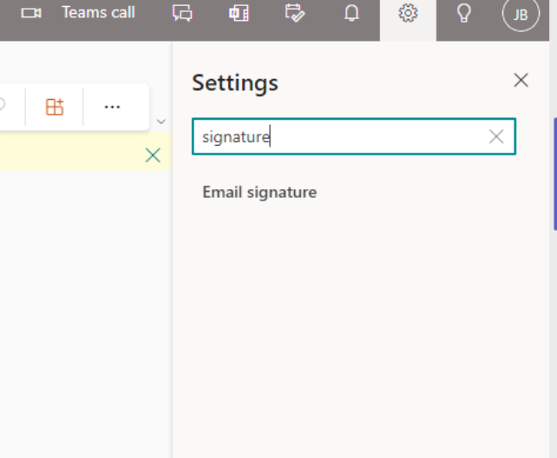

The below screen will appear. In the edit signature name box type what you would like to call your signature, for example your name

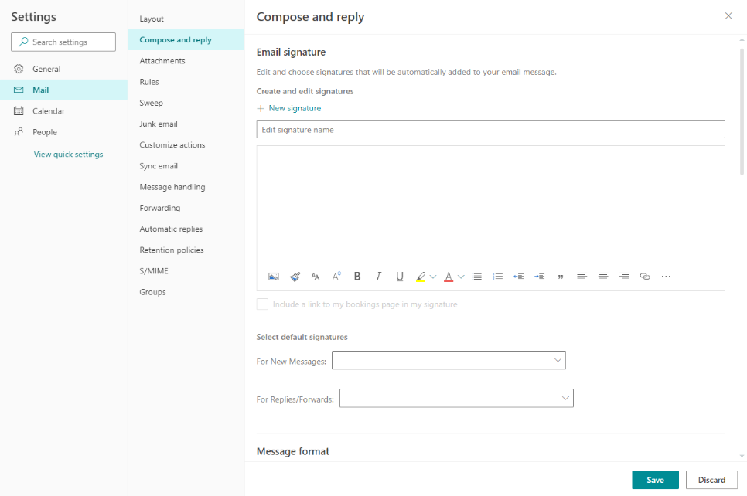
Next copy and paste the below template into the template box as shown below. You can edit your name and role into the areas indicated. The font, colour and size should remain the same.

Your name
Your volunteer role
Motor Neurone Disease Association mndassociation.org



Next, choose which types of messages you want your signature to appear on. We recommend selecting both New messages and Replies/forwards, and assigning your signature to each
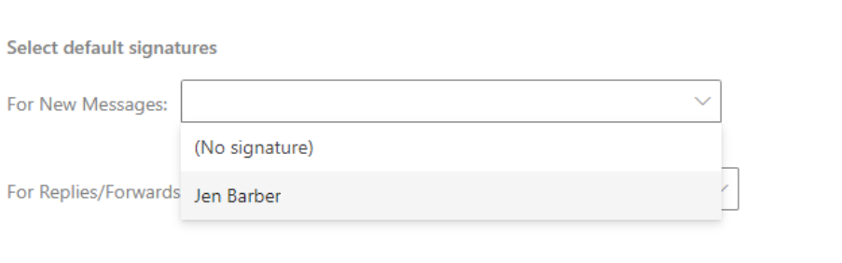

Your screen should look like the below showing your signature name.
Next click Save.

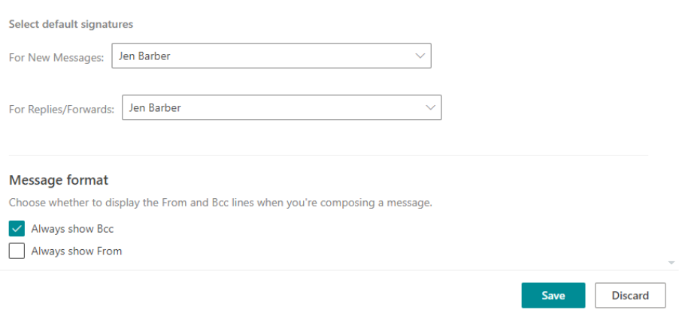

When you create a new email your signature will automatically display as shown below.
