
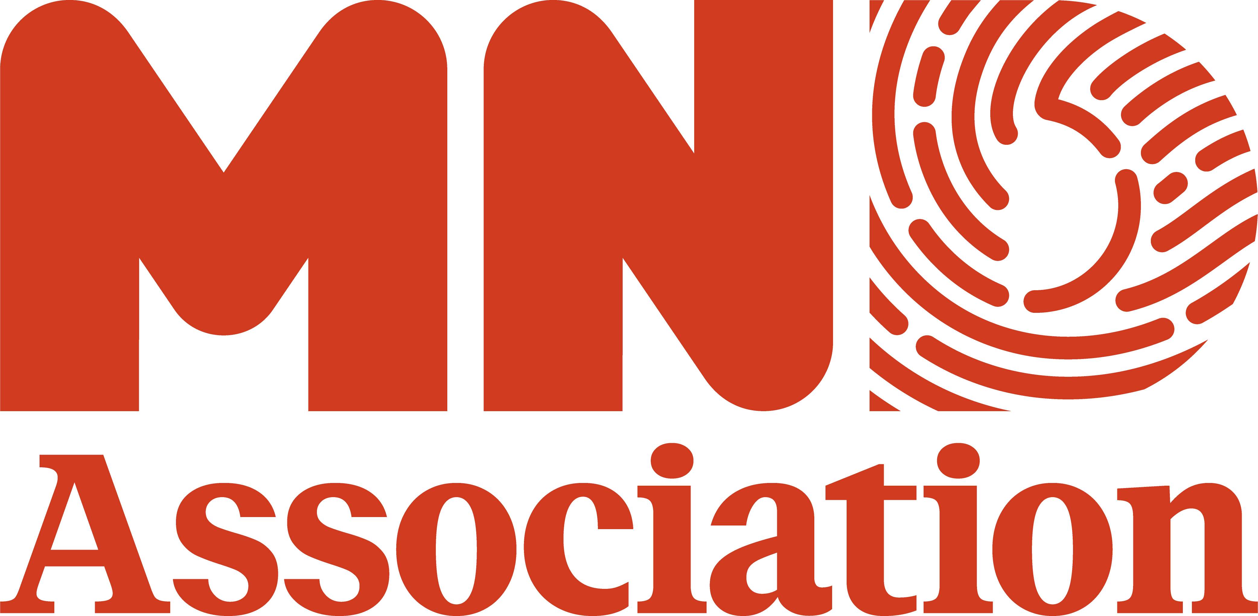

AGM OF THE ALL-PARTY PARLIAMENTARY GROUP ON MOTOR NEURONE DISEASE
Tuesday 17th March 2026
13:00 – 14:00pm
Room R, Portcullis House
f
Attendees | External Guests | Apologies
Michell Welsh MP  Michale Payne MP  Sarah Hall MP  Ian Byrne MP  Michael Wheeler MP  Olly Glover MP  Perrin Moon MP  James Wilde MP  Anna Dixon MP  Greg Stafford MP  Ben Lake MP  Baroness Ilora Finlay (our Patron)  Staff on behalf of Harpreet Uppal MP Staff of behalf of Paul Barker MP  Staff on behalf of Tessa Munt MP  Staff on behalf of Yvette Cooper MP | Sian Guest, MND Association  Alex Massey, MND Association  Alex Charilaou, MND Association  Stella Mckernan, MND Association  Dr Rachel Jakeman, representing Patients United to End MND  Chloe May, MND Association  Sean McGrath, Medical Strategy Lead, My Name's Doddie Foundation  Professor Ammar Al-Chalabi, King's College London  Members of the MND community  Sue Heal  Jessica Devnani  David Setters, Patients United to End MND | Aphra Brandreth MP  Adrian Ramsay MP

Meeting notes (condensed for brevity)

- Welcome and introduction

Ian Byrne MP welcomed colleagues and thanked them for attending the APPG. We were also joined online by members of the MND community via Zoom, alongside Sean McGrath, the Medical Strategy Lead from the My Name's Doddie Foundation, and Ammar Al-Chalabi, Professor of Neurology and Complex Disease Genetics at the Maurice Wohl Clinical Neuroscience Institute at King's College London (KCL).

- AGM: Election of Officers and Appointment of Secretariat

Ian held a vote on the election of each officer for the APPG on MND. The current chair of the APPG is Ian Byrne MP, and Vice Chairs are:

- Michael Payne MP
- Olly Glover MP
- Aphra Brandreth MP

Aphra Brandreth MP sent her apologies for the meeting.

All officers present voted in support of Ian Byrne continuing as chair and Michael Payne MP, Olly Glover MP and Aphra Brandreth MP continuing as Vice chairs.

He also held a vote on the continuation of the MND Association as the APPG's secretariat. All officers voted unanimously in favour of the association continuing as the secretariat.

- Baroness Casey’s Review

Ian began by outlining the work done by the MND Association over the last eight months to engage with the Independent Commission on Adult Social Care, chaired by Baroness Casey. The Association has organised two roundtables for people with MND to share their experiences with the Casey Commission, and engaged with occupational therapists and MND care coordinators to identify the issues affecting people with MND in relation to social care and support.

At the Nuffield Trust Summit on March 5th this year, Baroness Casey called for a fast-track passport to support for people with MND, recognising the complexity of the condition. Following this, the Secretary of State for Health and Social Care, Wes Streeting, responded in writing, committing to introduce a new process to speed up the time people with MND can access the care they need.

Ian went on to explain that this moment represents a real opportunity to address delays and the bureaucratic processes that affect people impacted by MND. The Association continues to work closely with the commission and the APPG to ensure these recommendations are translated into real, practical change for people with MND and their families.

The APPG Officers have written to the Secretary of State for Health and Social Care, thanking him and ensuring that those words are put into action. The APPG's goal is to ensure that those with MND can access support without unnecessary hurdles.

The Chair and Officers agreed to approach Baroness Casey to seek a meeting to discuss her recommendation and how it can be translated into action.

- Prescribe Life: Accessing a breakthrough MND treatment

Ian introduced the Prescribe Life campaign by briefly discussing the SOD-1 Summit. On the 14th January this year, MPs, MNDA, scientists, and people living with MND attended the SOD-1 Summit in parliament to discuss access to tofersen.

Ian highlighted that tofersen is a treatment that targets a specific genetic change in the SOD1 gene, which is known to cause MND. SOD-1 MND affects about 2% of the MND population. Tofersen has an unprecedented impact on the disease progression and life expectancy.

Tofersen is currently available free of charge to the NHS through an Early Access Programme. However, as there is no dedicated resource to support this activity, many trusts need additional resources to participate or expand participation, leaving patients without a route to access. With a further 28 patients forecast to be diagnosed with SOD1 MND over the next year, there are concerns both for patients currently missing out and those yet to be diagnosed. Due to the speed of MND progression, access to tofersen is an urgent need.

Michael Payne MP and Ian have agreed to discuss the situation regarding access to tofersen directly with Ministers Wes Streeting and Zubir Ahmed.

Ian highlighted actions taken by the APPG, including meeting with Zubir Ahmed. Alex Massey reported back from a meeting with Zubir Ahmed and NHS England attended by him and Tanya Curry, MND Association CEO. He mentioned that it was a productive discussion, and that NHS England has been instructed to contact participating trusts directly to understand the barriers to expanding access and consider potential solutions. However, the Government continues to argue that it cannot provide resource support directly until tofersen has received a positive NICE appraisal.

The NICE appraisal is ongoing but is not expected to conclude before December this year. In the interim it’s not clear where the capacity will come from to provide access to those who need tofersen, in the absence of additional resource.

- Survey data: SOD1 MND numbers and genetic testing status

Stella McKernan provided an overview of the current tofersen access picture. The Association has engaged with the 24 specialist care centres and networks which provide care to over 3500 people with MND across the UK. There are c.80 people that we know of with SOD-1 MND in England, Wales and Northern Ireland.

Of the 24 MND Care centres and networks we surveyed, 10 of them are currently delivering tofersen via the Early Access Programme (EAP), this includes Sheffield, Kings, Oxford, St Georges, Sussex, Birmingham, Lancashire and South Cumbria, Manchester, South Wales and Northern Ireland. 5 are in progress to deliver at various stages, things like allocating the resource which takes time and gaining trust approval and lastly 9 are currently not delivering, some of which include Leeds, Barts, Queens Square, Newcastle, Liverpool and North Midlands. *

17 people with SOD-1 MND are being referred to centres for tofersen from out of area and will now be eligible for support through the Association’s new Tofersen Travel Fund. There are c.55 people receiving tofersen currently and we are aware of 13 people missing out currently.

Trusts and centres reported barriers to delivery including: bureaucratic hurdles, such as the need for new procedures and protocols; senior leaders not supporting due to the non-drug related costs in funding delivery; lack of clinic space and clinical capacity. While the access picture has improved, the clinicians involved have made it clear that getting to this point this has not been easy. It has taken significant time and resource on top of their existing responsibilities.

Dr Rachel Jakeman highlighted the need to work together to make sure people from all UK nations gain access, particularly in Scotland where no tofersen delivery is currently taking place.

Sarah Hall MP asked the following question: “On the protocols, if there are successfully implemented systems why is it taking so why aren’t trusts sharing protocols amongst themselves?” Stella noted different trusts have different protocols and different needs based on staffing, but agreed with the value of information and resource sharing.

Dr Rachel Jakeman, Unite to End MND, stated that the protocols and costings varied for Tofersen delivery depending on whether an interventional radiologist/research fellow or Physicians associate delivered the intrathecal pathway. She then explains that different areas have different approaches, therefore, it's so important for us to share knowledge. “For example, the King’s pathway has been going for 9 years, where my stepdaughter is going, and it was the physician assistant who delivered the intrathecal injection.”

Perran Moon MP introduces the topic of access to medicines in rural and coastal areas. He then explained that it would be great to have a brief to clarify the key asks around the APPG. His best friend has just been diagnosed with MND and has already raised 50k for the MND Association. They are hoping to do a fundraising event in June in Cornwall.

Anna Dixon MP raised her interest social care and a desire to collaborate with Ian Bryne MP around the Casey Commission. They agreed to discuss further following the meeting.

*These numbers have since updated: There are now c.83 people that we know of with SOD-1 MND in England, Wales and Northern Ireland.

Of the 24 MND Care centres and networks we surveyed, 12 of them are currently delivering tofersen via the Early Access Programme (EAP), this includes Sheffield, Kings, Oxford, St Georges, Sussex, Birmingham, Lancashire and South Cumbria, Manchester, Barts, London the National, South Wales and Northern Ireland. 3 are in progress to deliver at various stages, things like allocating the resource which takes time and gaining trust approval, and lastly 9 are currently not delivering. 18 people with SOD-1 MND are being referred to centres for tofersen from out of area and will now be eligible for support through the Association’s new Tofersen Travel Fund. There are c.57 people receiving tofersen currently and we are aware of 13 people still awaiting treatment.

- Genetic testing

Genetic testing has become an increasingly important element of the MND pathway. Access to treatments like tofersen are triggered by results to a genetic test. As of April 2023, everyone with MND diagnosis is eligible for a diagnostic genetic test. NHS England guidelines states that as a rare disease results of these genetic tests must be shared within 84 days from when the sample is received at the lab. In 2025, we heard that people with MND were waiting up to 18 months to receive their genetic test results.

Since early last year, the MND Association has been engaging with NHS England around delays to genetic testing for people with MND. This led to the implementation of an interim system in England that allows labs to report MND tests and positive findings of SOD-1 mutations sooner. This system was implemented in areas of England with the longest wait times. Through its recent engagement with MND Care Centres and Networks, the Association found all centres in England and Wales are now routinely offering genetic testing to everyone with MND. Turnaround times for results have reduced to 3-4 months, representing significant improvement from last year.

Ian Byrne asked the following question: “How long should it take to receive a genetic test result?” Professor Ammar Al-Chalabi responded to Ian Byrne MP’s question, stating that it should take Ideally three to four weeks. Stella explained that the Association is working to explore a proposal for a faster reporting pathway for the ‘big four’ genes associated with the majority of familial/inherited MND cases.

- Comments from Dr Rachel Jakeman

Dr Jakeman spoke about attending the SOD-1 Summit in January. She attended in support of her stepdaughter, who was unable to access tofersen in Southampton and is a GP. Lilia has since gained access to tofersen. Rachel referred to the delivery network set up by Dr Alex Thompson of the Oxford MND Care Centre and discussed the importance of working in a coordinated way across the country to address the barriers to tofersen access. Rachel argues that how tofersen is addressed now can help provide a model for other precision medicines in the future.

Professor Al-Chalabi noted that even if and when NICE approves tofersen and it is commissioned, we will still need a mechanism to show which sites can take patients and which cannot. The reality is that even when tofersen is commissioned, there is likely to still be centres unable to deliver services. A central database would be suitable in this situation.

Ian concluded this section by saying that the APPG on access to medicines and medical devices, chaired by Danny Beales MP, will meet next Tuesday, 24th March, to discuss issues with early access programmes. Patient organisations have been invited to attend, and the Association will be in attendance and will update on this at the next APPG meeting.

- Questions & AOB

Jessica Devani noted that Stella mentioned the possibility of fast-tracking the SOD-1 tests, and asked what the consensus is on a suitable timeline.

Stella responded to Jessica’s question, highlighting that the Association is exploring this issue currently. Professor Al-Chalabi argued that we would want the ‘big 4’ genes associated with MND to be fast tracked in relation to genetic tests. This would enable people to access treatments earlier.

Sean McGrath asked a question around other diseases and the standards of care for drugs. “For me, I think there should be more standards of care for those who have MND, so that people are measured. I would propose we set up some standards of care that are set up across the UK for every patient that is diagnosed, and what happens to them, including genetic testing.” Stella responded, noting that the Association has been speaking to NICE about the inclusion of genetic testing within the NICE guidelines for treatment and management of MND.

Sean McGrath followed up, noting that the situation is different in Scotland because the turnaround time for genetic tests is quite short. But not everyone has access to tofersen because the system requires a family background. It’s more complex, but I think there could be a standard of care applied everywhere in the UK, driven by clinicians, charities, and patients.

Emma McClellan agreed with everything said, particularly regarding Amaar and the big 4 genes. “As I have mentioned previously, my son had the FUS mutation, and with FUS in particular, the decline is very rapid. Now, treatments are coming that are very promising. I would wholly endorse thinking of the big 4, particularly thinking about how things are in the ideal world.”

Rachel encouraged attendees to also recognise that some people who should have had a genetic test have not had access historically. We need to make sure that they do.

Jessica noted in relation to the Casey Commission that there have been 22 major reports on social care over 37 years and asked how a cross-party group like the APPG comes together to ensure cross-party solutions to social care.

Ian responded, stating that we have to come together as a collective and push these recommendations. He added that the APPG should be talking about standards of care and ensuring there is consistency in access and delivery of treatments across all nations.

Perran Moon argued that in the short to medium term, there is unlikely to be change in government over the next three years. Therefore, there is an opportunity to push for the implementation of the Commission’s recommendations with the current administration.

Ian answered a final question around the appraisal process of tofersen with NICE. He suggested that it might be worth speaking to the health committee about how to best approach each stage and overall learn from what has been done successfully in recent years.

9. Close

Ian draws the meeting to a close and thanks everyone for attending.

